**IMPROVING ZARA’S MOBILE APPLICATION’S USER INTERFACE**

**Part 4: Final Report**

**CPS613 - Human-Computer Interaction**

**Dr. Somang Nam**

Chloe Parentela

Dylan Rodrigues

Ghazal Mirsayyah

Omar Syed

Shantanu Singh

**April 14, 2022**

# **Table of Contents**

**Table of Contents** **2**

**Summary** **4**

**Introduction of Problems to be Solved** **5**

**Initial User Research Summary** **5**

Quantitative Analysis 6

Qualitative Analysis 6

**Low-Fidelity Prototype** **7**

Links 7

Screenshots 7

**Heuristic Evaluation Results** **8**

**High-Fidelity Prototype** **9**

Links 9

Start Page 9

Login and Signup Pages 9

Bottom Navigation Bar 9

Home Page 10

Search Page 10

Single Item Page 10

Menu Page 11

Profile Page 11

Shopping Cart Page 11

Wishlist Functionality 12

Errors 12

**User Testing Strategy** **13**

**Analysis of High-Fidelity Prototype’s User Testing** **14**

**Future Works** **22**

**References** **23**

**Appendix** **24**

Low-Fidelity Prototype 24

Start, Login, and Signup Pages 24

Home Page 24

Searching For an Item 25

Menu Page 26

Profile Page 26

Shopping Cart Pages 27

Wishlist 28

Consent Form 29

Data Collection Form 31

Raw Data From User Testing of the High-Fidelity Prototype 42

Graphs and Figures 53

# 

# 

# 

# 

# **Summary**

My group and I began this project by identifying possible user interface problems with Zara's mobile application. We proceeded to conduct a literary review for the identified problems while researching possible solutions for them. By conducting an initial benchmarking analysis of the identified problems with Zara’s original application, we were able to determine the effects they were having on the general user. For our next step, we conducted user studies through a survey to judge the performance of the original Zara platform. Based on the results of the survey, we were able to perform an analysis of the collected data and proceed with the construction of a low fidelity prototype of our re-worked Zara mobile application. My group and I provided descriptions for operating our low fidelity prototype by creating use cases for scenarios of how users would interact with our prototype. Next, we gathered feedback from another group for our low fidelity prototype and based on their feedback, we were able to construct a high fidelity prototype. We then proceeded to document each application page for our high fidelity prototype. Within the documentation, we explained how each page operates and our reasoning behind each design choice implemented as well as providing pictures of the documented pages of our prototype. My group and I went on to create a user testing plan by using the DECIDE framework. This testing plan is in the form of a survey based off of our high fidelity prototype. My group and I then implemented the user testing in the form of a survey for our high fidelity prototype. We conducted a thorough analysis of the high fidelity prototype survey responses. Afterwards, we compared the results of the high fidelity analysis with the initial user research results of the original Zara application. Finally, my group and I listed ideas we would implement into our application in the future.

# **Introduction of Problems to be Solved**

The problem that we wanted to solve for our project were issues with Zara’s mobile application. In our initial perusal of the application, we noticed several problems that detracted from the overall user experience. To begin with, the categories the products were organized by were very counterintuitive and hard to work with. The forms were unlabeled and confusing, and left users wondering which fields were required or not. Another problem in major need of a solution was navigation: Zara’s minimalist design makes navigating through the site difficult and hard to learn quickly. Buttons are also placed in unexpected areas and are hard to understand due to their size and formatting. Finally, the carousels are also hard to understand due to their inconsistent design, inefficient functionality, and illegibility. In order to fix all of these problems, we made a redesigned version of the current Zara application.

# **Initial User Research Summary**

Our initial user research revolved mainly around determining the issues present in Zara’s current mobile application. In our internal discussions and while developing the proposal documents, we aimed for the project to tackle various usability issues of the application. They included the product category, size of the buttons and general issues with the overall navigation interface. After a few pain points were identified, we created a survey to determine that these pain points also resonated with Zara’s target demographic population. Our survey finds were divided into two categories:

## Quantitative Analysis

We focused our survey on gaining valuable insights from Zara’s target demographic. Our respondents were mainly between 18 to 23 years of age. This ensured that our survey data, analysis and conclusions were in line with the sentiments of the general shopping population.

In order to assess the usability of Zara’s current mobile application user interface, we employed the design-standard System Usability Scale (SUS) questions. Zara’s design scored a 55.91 as its average SUS Score, well below the acceptable 68.5 limit (Sauro, 2018). 73% of the calculated SUS Scores were below the acceptable 68.5 threshold.

Our quantitative analysis also showed that the users were mainly dissatisfied with the button size, distinguishability and discoverability with the survey respondents specifically struggling to locate the live chat and the “Terms of Use” buttons. 73% of our respondents indicated that they struggled significantly with locating them. Therefore the quantitative analysis of our survey data was in conjunction with our proposed problems and we could proceed with the development of the low-fidelity prototype.

## Qualitative Analysis

The qualitative analysis revealed insightful information about Zara’s platform. Since Zara hosts an equal variety of clothing for men and women, our survey had a healthy mix of both, with 56% of the respondents identifying as women while the remaining 44% identified as men. This balance in respondents ensured that our collected data would properly depict the majority of Zara’s online customer base. We asked the participants whether or not they are well-versed in online shopping. Our surveys showed that approximately 90.9% of respondents preferred use of mobile apps for online shopping with 81.8% of respondents being very well-versed with online shopping. After building credibility of the users, as all respondents indicated that they either sometimes or often shop online, we proceeded to ask about the structure and functionality of Zara’s mobile application. The qualitative analysis of the survey showed that approximately 7 out of 11 respondents felt that the overall menu layout of Zara’s application performed below standard while none of the respondents seemed to be very satisfied. The respondents showed most conflict with the carousel interface presented to the user at the landing page, as majority of the respondents indicated issues using it. Respondents indicated that the structure of the carousel interface was difficult to work with and the general layout of the whole Zara application was not intuitive.

# **Low-Fidelity Prototype**

## Links

The page:

<https://www.figma.com/file/npCWEZato3i6FDwFSETn4r/CPS-613?node-id=0%3A1>

The running prototype:

<https://www.figma.com/proto/npCWEZato3i6FDwFSETn4r/CPS-613?node-id=3%3A105&scaling=scale-down&page-id=0%3A1&starting-point-node-id=3%3A105>

## Screenshots

For screenshots of the low-fidelity prototype, refer to the “Low-Fidelity Prototype” section of the appendix.

# **Heuristic Evaluation Results**

| **CASE#** | **Q1** | **Q2** | **Q3** | **Q4** | **Q5** | **Q6** | **Q7** | **Q8** | **Q9** | **Q10** |
| --- | --- | --- | --- | --- | --- | --- | --- | --- | --- | --- |
| **1** | 0 | 0 | 0 | 3.5 | 0 | 0 | 2 | 0 | 4 | 0 |
| **2** | 2 | 0 | 0 | 1 | 0 | 2 | 0 | 0 | 0 | 0 |
| **3** | 2 | 3 | 2 | 3 | 4 | 0 | 0 | 3 | 0 | 2 |
| **4** | 2 | 0 | 3 | 1 | 0 | 0 | 2 | 2 | 4 | 2 |
| **AVG** | 1.50 | 0.75 | 1.25 | 2.13 | 1 | 0.50 | 1 | 1.25 | 2 | 1 |

**Table 1**: Data of Heuristic Evaluations

Our group performed heuristic evaluations based upon four different user stories, which were sign up and log in, looking for a specific item, buying an item, and general analysis. While 8 out of 10 heuristics were rated on average as less than a minor problem, we can see that heuristics 4 and 9 stick out as more than minor problems.

Heuristic 4, which is Consistency and Standards, had an average rating of 2.13. Users noted problems they had with the login and sign up pages, such as not being asked for their first and last name. Another user noted the lack of shipment options, such as home delivery, store pick-up, or pick-up points. Both of these have since been patched in the high-fidelity prototype by adding additional account details during sign-up, and more shipment options during checkout.

As for heuristic number 9, which is Error Recovery, both users who gave a rating of 4 noted a lack of error messages both within the sign-up page, and throughout the general app. This has also since been fixed in our high-fidelity prototype by adding error prevention prompts for actions such as deleting items, and error messages for incorrect/incomplete text-fields such as passwords.

# **High-Fidelity Prototype**

## Links

The page:

<https://www.figma.com/file/CEZv9yBqSiPFkQeEnn7gSY/CPS-613%3A-High-fidelity?node-id=0%3A1>

The running prototype:

<https://www.figma.com/proto/CEZv9yBqSiPFkQeEnn7gSY/CPS-613%3A-High-fidelity?node-id=3%3A105&scaling=scale-down&page-id=0%3A1&starting-point-node-id=3%3A105>

## Start Page

The first page displays an image of Zara’s most recent collection, with the logo clearly displayed at the top of it. It contains only three options to avoid overwhelming the users. The primary one is signing up, the secondary is logging in, and finally, the tertiary action is continuing as a guest.

## Login and Signup Pages

The login and signup pages ask all the necessary information for login and signup as per Zara’s original app. They also include more clearly defined input fields, labels, and placeholder texts. All the required fields have also been indicated as required by an asterisks (*) sign to make the forms’ requirements more clear for the user.

## Bottom Navigation Bar

The bottom navigation bar follows the original design with two important improvements: firstly, the icons are larger and thicker, and the active state of the search icon has been changed to make it more clear as the active page, as it was hard to notice in the original design. Secondly, the shopping cart icon has been changed to match real world examples more closely.

## Home Page

Zara’s original design for the home page has been radically changed for the prototype. The cumbersome carousel interfaces have been removed, and replaced with a mixture of images and videos to make the page attention-grabbing.

## Search Page

The redesigned app’s search page follows the original design closely, with the only notable change being the increased size of the elements and the font. In contrast, the search results page is very different from the original one. Instead of two items in a row with the name and price written underneath in small font, the new design only has one item per row with name, price, special tags (discount, new collection, out of stock, etc), and the ability to add the item to wishlist right away, all with bigger fonts. The filter functionality also allows for sorting the items based on more criteria than the original app, and also shows how the user is filtering using the current criteria.

## Single Item Page

The single item page in the new design uses a horizontal carousels instead of the original app’s vertical one, with three ways of scrolling instead of one: dragging left and right (as per the original app), using the scroll indicators, or tapping on one of the smaller pictures at the bottom (the active picture has a dark mask layer over it). It also shows the item information right away (in the original app, the user has to pull up the information overlay), with clear labels for colors and sizes, and bigger fonts. It also allows the user to choose the quantity by either using the - and + signs after clicking on the “Add to cart” button or typing in the quantity (in the original app, the user has to click on “Add to cart” multiple times to get more than one of the item, and is only able to see the quantity in their shopping cart).

## Menu Page

The number of items in the menu page have been reduced to decrease the users’ sensory overload, and to make it easier for them to find their desired category. To do so, the new design groups related categories together (maximum two categories) and instead gives the user the ability to see them one category at a time (or all at the same time) in the results page.

## Profile Page

The profile page follows Zara’s original design closely, with bigger fonts and more distinguishable buttons. It also no longer uses Zara’s scrollable horizontal menu of options, and instead lists them vertically on the same page. Some relevant shortcuts have also been added to this page, namely live chat, wishlist, privacy policy/terms and conditions, purchase history, and logout.

## Shopping Cart Page

The shopping cart page has been significantly improved in the new design. The shopping cart/wishlist switch bar has been changed to keep consistent with the rest of the app. The font is significantly bigger, and all data fields have been labeled (e.g: price, color, etc). The quantity indicator has been changed so that the user has two ways of changing it (-/+ signs and typing a number). The new functionality of editing an order has also been added, which allows the user to edit the characteristics of an item (e.g: color, size, etc). The pick-up method has also been added to the same page, so the user can change the method and see its effect on the price immediately. “Help”, “Settings”, and “Chat with us” options have also been added to every step of the checkout process to help the user with their questions or needs at any step of the process.

## Wishlist Functionality

The new design of the app allows the users to add items to their wishlist by two ways: by either adding it from the icon at the top of the item’s pictures in the results page, or the icon on the right hand side of the single product page. After clicking on the icon, the user is prompted to add the item to an already existing wishlist collection or to make a new one. The wishlist can be accessed both from the profile page and the shopping cart page, where the user can see, edit, and remove their wishlist collection(s).

## Errors

As per feedback received from the heuristic evaluations, multiple error prevention functionalities have been implemented. When the user wants to delete something, for example remove an item from their cart, they are prompted with a message that asks them to confirm their decision. Furthermore, to prevent them from entering wrong information, placeholder texts have been added to form fields, as well as error messages that come up when the user enters the wrong information explaining the problem and offering ways for resolving the problems (they cannot be seen in the running prototype since Figma does not allow for accepting inputs, but they can be seen in the error frame on the left side of the Figma page).

# **User Testing Strategy**

User Testing of our high-fidelity prototype dictated a similar testing procedure to our previous surveys. For our user testing, we used the DECIDE framework which involved **D**etermining our goals with respect to our testing, **E**xploring the suitability of questions to be asked during the testing, **C**hoosing and finalizing the evaluation approach to ensure that the high-fidelity prototype is effectively evaluated, **I**dentifying practical issues, **D**iscussing and dealing with any ethical issues, and finally **E**valuating, analyzing and interpreting the data. The next section deals with the analysis of our user testing.

The strategy involved participants testing our high-fidelity prototype live while we timed them and answering questions in a Google Forms survey. We asked similar questions to our previous survey which were based on the System Usability Scale (SUS) and general user interface questions. This was done to ensure the standardization of questions asked in both the surveys in order to compare score differences and to track and to be able to quantify usability improvements compared to Zara’s current mobile interface with our redesigned high-fidelity prototype. In addition, we asked the participants to perform a list of tasks which were recorded and timed. This allowed us to quantify our findings and test whether our high-fidelity prototype performs well with Zara’s target demographic and iron out any last minute design-related issues or bugs.

User Testing was a crucial part in the development of our high-fidelity prototype. With frequent testing at every stage of the design and implementation process, we were able to determine whether or not participants are capable of effectively completing given tasks in our brand-new redesign, the level of satisfaction with our redesigned application among respondents, and if any modifications must be made in order to increase user performance and experience.

# **Analysis of High-Fidelity Prototype’s User Testing**

First, we started off by asking some demographic questions in our survey. As can be seen from the charts in the appendix, the majority of the users who did our survey were either in the 18-23 age group (Figure 1) with a minority from the older age groups. They were also mostly female (Figure 2). This fits with the expected demographics for the Zara application (Figure 3). The users also shopped online occasionally but were familiar with Zara (Figure 4). They were also mostly mobile users (Figure 5).

Quantitative Analysis

Next, we will perform analysis on the results of our survey on the usability of our redesigned version of the Zara application. The survey asked users to do various tasks, timed them and asked about their satisfaction and the complexity of the task. First, we will begin the description of the quantitative data.

For the **first task - creating an account** - the mean time that users expected to spend was around 40 seconds while the median and mode were 30 seconds (Figure 6). However, once the users were actually timed doing the task (Figure 7), the mean time it took was 27 seconds, while the mode was 25 seconds. Based on this, we can conclude that the amount of time it took to create the account in the redesigned application fit mostly within what users expect to encounter. Meanwhile, Figure 8 in the appendix shows user responses to being asked about the complexity of creating an account, with a scale from 1-5; 1 being very complex at all and 5 being very easy. The mean of the user responses was 4.2 while the median and mode was 4.5 and 5. The Interquartile Range (IQR) was 1. Most of the users seem to agree that making an account even on the redesigned application was very easy and the low IQR indicates that most of the users agree on this. Figure 9 in the appendix indicates how many users were satisfied with the redesigned application when it came to the process of making an account. The mean here is 4.2 while the median and mode is 4. The IQR here is 1. Once again, most users widely agreed that they were satisfied with the redesigned application.

Next is **task 2: searching for items**. Figure 10 in the appendix shows how much time the users expected for it to take to find a particular item in the redesigned application. The average time that users expected was around 31 seconds, with the maximum value being 60 seconds and the minimum being 5 seconds. The median and mode were 20 and 60 seconds, respectively. Figure 11 in the appendix demonstrates that the maximum amount of time it took users to find an item on the redesigned application was around 45 seconds while the lowest amount of time was 10 seconds. This shows that the redesigned application is close to the users’ expectations when it comes to the amount of time needed to find an item. Our next question asked what the complexity of finding a pink bag was, from a scale from 1-5 with 5 being very easy while 1 was very complex. The users’ responses are illustrated by Figure 12 in the appendix. The mean of the user response was 4.8 while the median and mode were 5. The IQR was 0. This shows that users overwhelmingly found the experience of searching for the specified item on the redesigned application very easy. Figure 13 in the appendix below, however, shows the amount of satisfaction that users felt with the redesigned application. The Likert scale question we asked had a scale of 1-5, with 5 being very satisfied and 1 being very unsatisfied. The mean here is around 4.3 while the median is 4.5 and the mode is 5. This shows that the vast majority of the users were very satisfied with the redesigned application when it comes to being able to find items, with little polarization.

The next task was **adding and removing items from the Wishlist in the redesigned application**. Figure 14 in the appendix below shows the wide range of responses we got to the question of how much time users expected to spend on this task. The mean time was 39 seconds; the minimum and maximum time was 2 and 120 seconds, respectively. The actual time it took to complete the task was between 5 and 52 seconds, which is well within our users’ expectations (Figure 15). To get user input for this task, we asked users to pick any item on the homescreen and to add it to the wishlist. Figure 16 in the appendix below shows how complex the users found this. The question used a Likert scale, with 1 being very complex and 5 being very easy. The mean here is 4.1 while the median and mode is 4; the IQR is 1. This shows that the vast majority of the users found the task of adding items to the Wishlist somewhat easy. Figure 17 in the appendix depicts the results of a Likert scale asking about how satisfying the process of adding items to the wishlist was for the user. Here, the mean is 4.4 while the median is 4.5 and mode is 5. The IQR for the user responses was 1. This shows the vast majority of users were satisfied with no polarization.

Thenext task was **purchasing an item**. Figure 18 in the appendix shows the amount of time in seconds that users expected to spend on this task. The mean was 83 seconds, the max amount of time users expected to spend was 300 seconds while the minimum was 2 seconds. However, in actuality, Figure 19 in the appendix shows that the maximum amount of time that users spent on making a purchase was around 130 seconds while the minimum was around 5 seconds. Thus, the redesigned application falls within the amount of time that users expected. For this task, users were asked to go to their cart and purchase the item(s) there. Next, a Likert scale question asked the user how complex they found the task. The scale was from 1 to 5, with 1 being very complex while 5 was very easy. Figure 20 shows how complex the users found the task of purchasing items in the cart. The mean here is 4.3 while the median is 4.5 and the mode is 5; the IQR is 1. This shows that the majority were unanimous in agreeing that the task in the redesigned application was easy. However, Figure 21 in the appendix shows the same results for the Likert scale that inquired about the users’ satisfaction with the task. Thus, it seems that yet again the majority of the people unanimously agreed that they were satisfied with how the redesigned application handled the purchasing of items.

The final task was **finding the live chat feature** in the redesigned Zara application. Figure 22 in the appendix shows the amount of time in seconds that users expected to spend on this process. The average amount of time in seconds was around 25 seconds; the maximum was 30 seconds while the minimum was 4 seconds. However, as Figure 23 in the appendix demonstrates, the maximum amount of time spent on this task was 62 while the least amount of time was 3 seconds while most users took around 20 seconds. So mostly, the users took around the expected amount of time but there may be occasions where the task might take more time than expected. When it comes to rating the complexity of the task, we made another Likert scale from 1-5, with 1 being very complex and 5 being very easy. The results are shown in Figure 24 in the appendix. The mean, median and mode are all 4 while the IQR is 2. This shows that the vast majority of users agreed that finding the live chat feature in the redesigned application was quite easy, with very little disagreement. Lastly, Figure 25 in the appendix records the level of satisfaction the users had with the task. 1 is very unsatisfied while 5 is very satisfied. The mean is 4.1, the median is 4.5 and the mode is 5 while the IQR is 2. This shows that the users are mostly quite satisfied with finding the live chat task, with little disagreement.

Qualitative Analysis

Next we will perform a qualitative analysis based on the aforementioned survey regarding the usability of our improved interface for Zara’s mobile app. Participants were asked for any suggestions they may have towards our application, as well as various UI element questions such as satisfaction with the redesigned buttons, ease of finding buttons, ease of operations, and satisfaction with menu categories.

As shown in Figure 26, participants were asked how satisfied they were with the size, distinguishability, readability, and discoverability of the buttons. The results for both the size and distinguishability are identical, with the majority of participants very satisfied, and the lowest result being neutral. This shows us that participants generally had no problems with the size or distinguishability of the buttons. As for readability, all participants were either very satisfied or somewhat satisfied, which shows that none of the participants had a problem with the readability for the buttons. Lastly, discoverability of the buttons was poorly rated compared to the others, with one participant noting that they are somewhat dissatisfied, and the majority being somewhat satisfied. No participants stated that they were very dissatisfied with any aspect of the buttons mentioned.

Participants were also asked how easy it was for them to find 4 different buttons, including the Help button, Settings button, Live Chat, and the Privacy Policy/ Terms of Use button. As shown in Figure 27, for the Help button, the majority of participants reported having a somewhat easy time, which is low compared to the settings button, in which the majority of participants reported having a very easy time finding it. Results for the Live Chat button ranged from very easy to somewhat difficult, with the majority of participants reporting a somewhat easy experience. Lastly, the majority of participants reported the Privacy Policy and Terms of Use buttons to be somewhat easy to find. This shows us that participants were either satisfied or neutral with finding all buttons, except for the Live Chat button in which one participant reported having a somewhat difficult time finding it.

As shown in Figure 28, participants were asked to report how easy various operations are in the redesigned app, which includes finding clothing items, searching for items, and filtering their search. Finding clothing items seems to be the most positive with all responses being either very easy or somewhat easy. The responses for searching for items and filtering search both range from neutral to very easy, however the majority of participants reported searching for items to be very easy, and filtering search to be somewhat easy. While these results show that participants generally had an easy time with all three operations, it’s apparent that searching and filtering items could be improved.

The following seven questions were regarding participant’s satisfaction with our redesigned app’s menu categories, which have been simplified during the design process. The aspects of the menu categories that we asked participants to rate included the number of items, the font size, the division of general categories, sorting, figuring out/finding your size, and the overall layout.

Firstly, participants stated their satisfaction with the number of items displayed in the menu categories. As shown in Figure 29, the majority reported to be somewhat satisfied and three others reported to be very satisfied; however one participant reported to be somewhat dissatisfied, and another to be neutral, which shows space for improvement regarding the number of items.

As shown in Figure 30, for the font size, there was a very positive response with the majority of participants stating they were very satisfied with the font size, and one stating to be somewhat satisfied. This shows that we have made a positive change with the font size which was a previously noted problem with Zara’s usability.

Regarding the division of general categories such as Mens, Womens, Kids, and Beauty, as shown in Figure 31, the reports range from neutral to very satisfied, with an equal number of participants being either somewhat satisfied or very satisfied, and two to be neutral. While there is room for improvement, this shows that the large majority of participants are satisfied with our refined design of the general categories.

As shown in Figure 32, the majority of participants were somewhat satisfied with our app’s sorting feature. While 3 participants remained neutral, the majority response shows that participants are satisfied with the new sorting feature using various criteria, which was lacking in Zara’s original design.

Regarding the participants’ satisfaction with figuring out your size at Zara, as shown in Figure 33, the responses ranged from very dissatisfied and very satisfied. The majority of participants’ responses were either neutral or somewhat satisfied, however the somewhat dissatisfied and very dissatisfied responses show that there is room for improvement.

While the previous question pertained to finding your size at Zara (i.e. the size chart), the next question is regarding the user’s ability to select their size. As shown in Figure 34, the responses range from very dissatisfied to very satisfied, with the majorities being neutral and very satisfied. While the majority of responses were positive, one participant reported to be somewhat dissatisfied and another to be very dissatisfied. Considering that selecting your size is a very simple task, these responses show a need for improvement.

Lastly, as for the overall layout of the menu, as shown in Figure 35, there was a very positive response, with the majority reporting to be very satisfied, and the rest of participants remaining somewhat satisfied. This shows an improvement on the overall layout of our refined menu.

**System Usability Scale (SUS)**

We also used the System Usability Scale (SUS) to check what users thought overall about the redesigned version of the Zara application. The table below shows our raw data converted into scores from 1 to 5 (1 being “Strongly Disagree” and 5 “Strongly Agree”). The final SUS score was 82.5, which is above the accepted score, and shows major improvement from the original app’s 55.9.

| Person ID | Q1 | Q2 | Q3 | Q4 | Q5 | Q6 | Q7 | Q8 | Q9 | Q10 | Raw SUS Scores | SUS Final Score |
| --- | --- | --- | --- | --- | --- | --- | --- | --- | --- | --- | --- | --- |
| 1 | 3 | 2 | 4 | 1 | 4 | 2 | 4 | 2 | 4 | 1 | 31 | 77.5 |
| 2 | 3 | 2 | 4 | 2 | 4 | 3 | 4 | 2 | 4 | 2 | 28 | 70 |
| 3 | 4 | 2 | 4 | 1 | 4 | 2 | 4 | 2 | 3 | 1 | 31 | 77.5 |
| 4 | 4 | 1 | 5 | 1 | 4 | 2 | 5 | 1 | 4 | 1 | 36 | 90 |
| 5 | 5 | 1 | 5 | 1 | 5 | 2 | 5 | 1 | 4 | 1 | 38 | 95 |
| 6 | 4 | 2 | 5 | 1 | 4 | 1 | 5 | 2 | 5 | 1 | 36 | 90 |
| 7 | 3 | 2 | 3 | 1 | 4 | 1 | 4 | 3 | 3 | 1 | 29 | 72.5 |
| 8 | 4 | 2 | 5 | 2 | 4 | 1 | 5 | 2 | 5 | 2 | 34 | 85 |
| 9 | 5 | 1 | 5 | 1 | 4 | 1 | 5 | 2 | 5 | 1 | 38 | 95 |
| 10 | 5 | 3 | 4 | 2 | 4 | 3 | 4 | 2 | 4 | 2 | 29 | 72.5 |
|  |  |  |  |  |  |  |  |  |  |  |  | **82.5** |

**Table 2:** System Usability Scale Score of our redesign

# **Future Works**

Looking back on the last four months, through the coursework and our own research, we learned a lot about Human-Computer Interaction. Through our project work, we went through the prototyping process which was productive, exciting and nevertheless, fulfilling. We developed the prototype and implemented all essential functions, new UI design, and additional systems throughout our project. From redesigning the entire application’s layout and workflow to debating over a tiny button’s UI selection, we went through our research and review in order to maximize the user experience. During this process, we realized that a simple terminology or the position of a button could affect users' understanding of the product. We also realized that prototyping benefits the system design by showing stakeholders how this system would work before it becomes an actual product and sets clear expectations with developers on tasks that need to be finished to build the whole product. As we worked on the high-fidelity prototype, we realized that the important goal is to make sure that every component, interaction, navigation, and functionality works as it is designed to be. Our potential ideas for future work are:

* General wishlist for adding items to wishlist quickly
* Option for sending clothes back to Zara for recycling from the app
* Reselling refurbished items
* Returning items
* Changing the app to another country’s app (like Amazon)
* Adding a VR feature for trying out clothes
* Sharing items with others (very recently added to the original app)
* Using Artificial Intelligence (AI) technology like Natural Language Processing (NLP) to support voice assistant functions that could benefit older shoppers and improve the application’s accessibility.

# **References**

Sauro, J. (2018, September 19). *5 Ways To Interpret A Sus Score*. MeasuringU.<https://measuringu.com/interpret-sus-score/>

# **Appendix**

## Low-Fidelity Prototype

### Start, Login, and Signup Pages

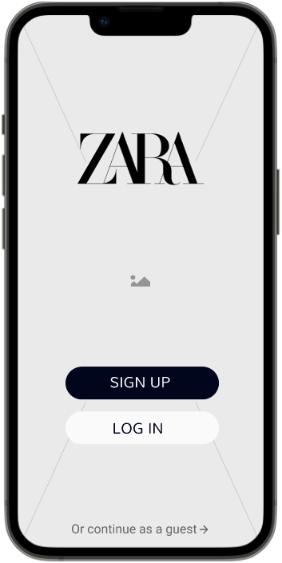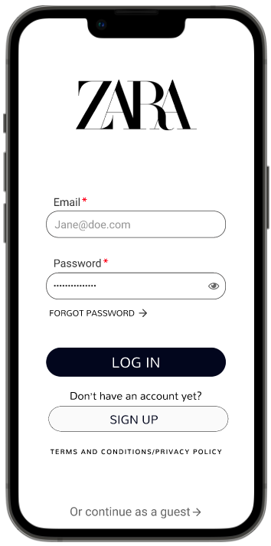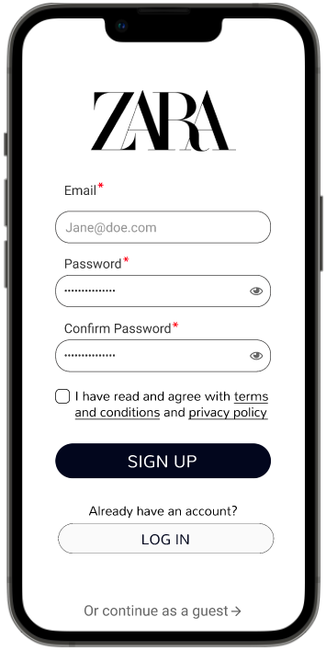

### Home Page

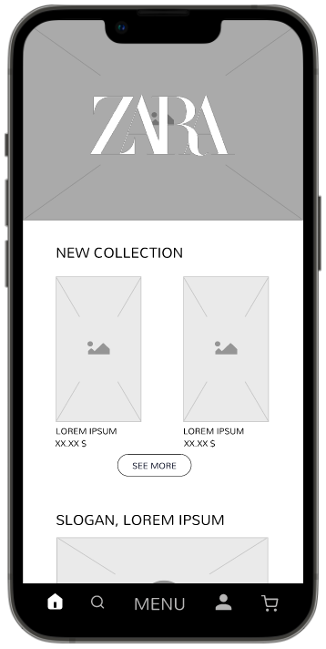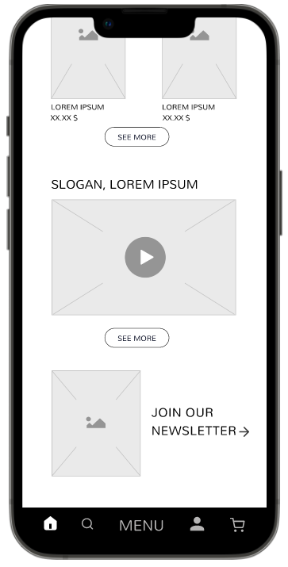

### Searching For an Item

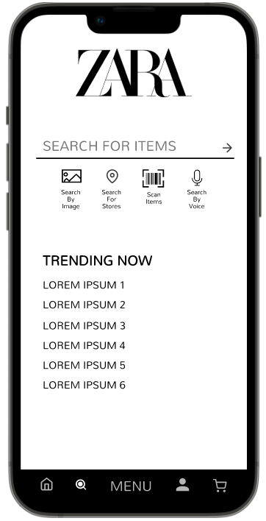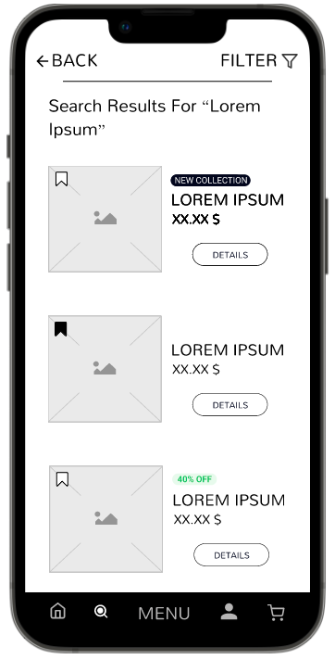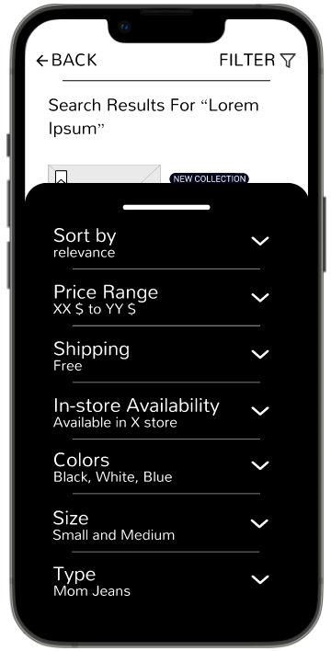

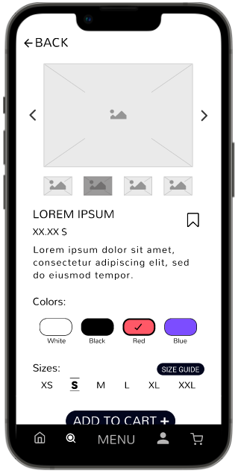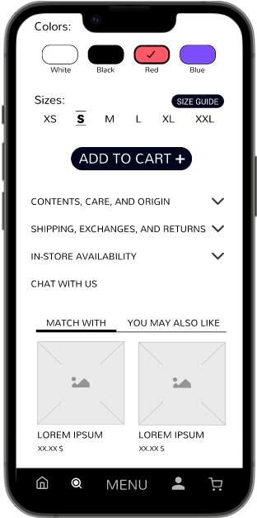

### Menu Page

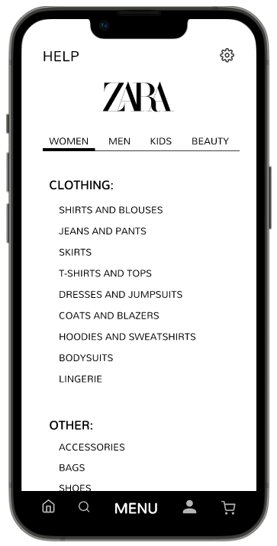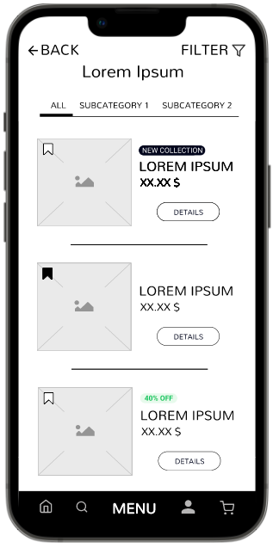

### Profile Page

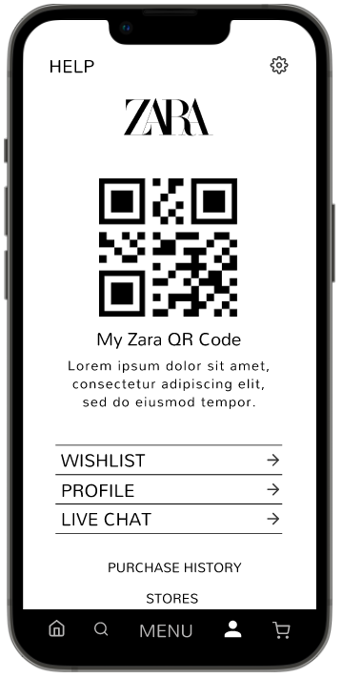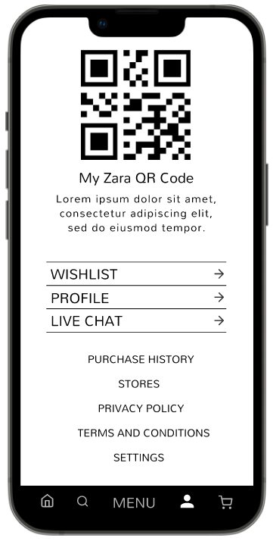

### Shopping Cart Pages

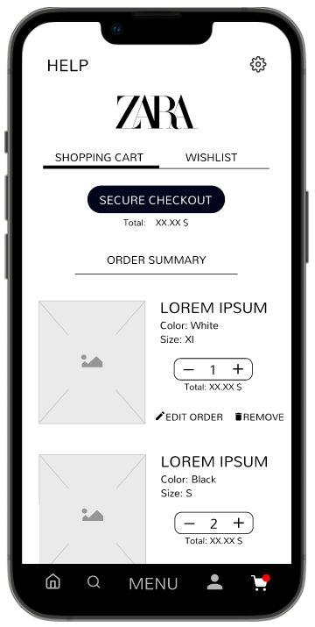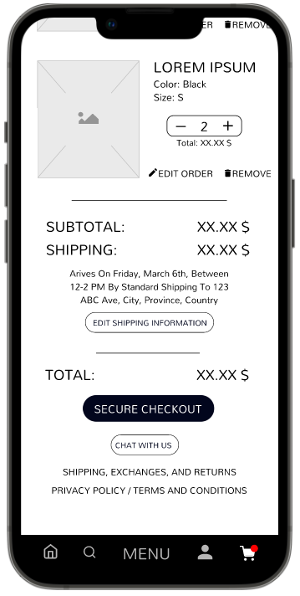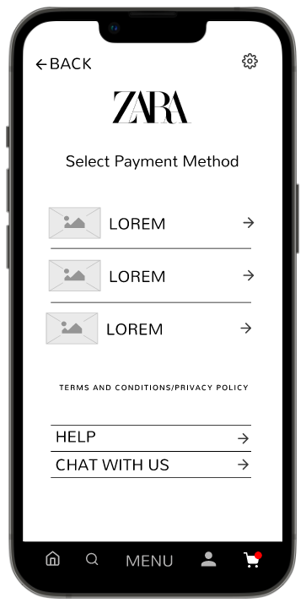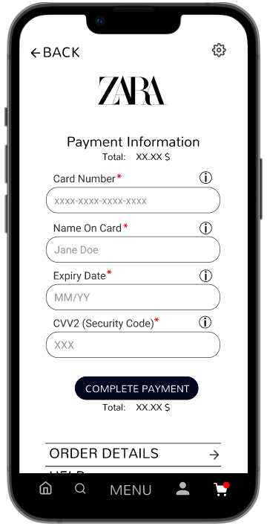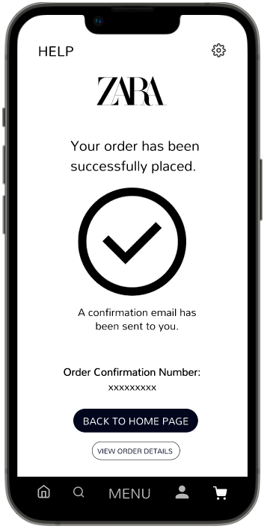

### Wishlist

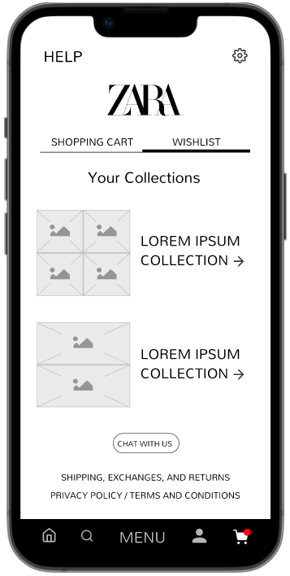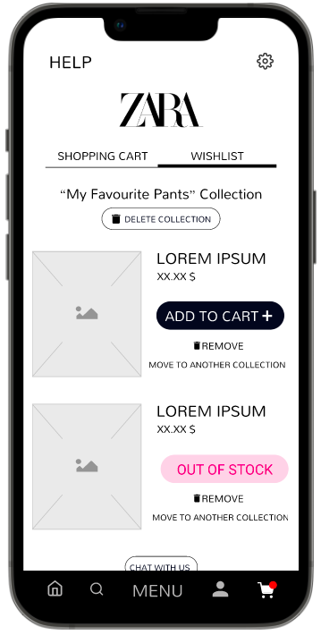

## Consent Form

**Improving Zara’s Mobile Application’s User Interface**

I hereby consent to participate in a study conducted by Chloe Parentela, Dylan Rodrigues, Ghazal Mirsayyah, Omar Syed, and Shantanu Singh for an assignment for Ryerson University’s CPS 613 course, Human-Computer Interaction.

I agree to participate in this study, the purpose of which is evaluating the redesigned Zara's mobile application from the users' perspective.

I understand that:

1. The procedures to be used are answering a few demographic questions, using different functionalities of the redesigned application, and filling out a questionnaire about them.
2. I agree that my mobile/desktop screen will be shared and used by the survey facilitators to study and gain insights on user behavior.
3. I will receive no compensation for my participation.
4. I am free to withdraw before or at any time during the study without the need to give any explanation.
5. All materials and results will be kept confidential, and, in particular, my name and any identifying or identified information will not be associated with the data.

**Participant**

| What is your name? |  |
| --- | --- |
| Please read the above conditions and sign your initials if you consent to them. |  |
| Today’s Date |  |

**Investigators**

| **Name** | **Signature/Initials** |
| --- | --- |
| Chloe Parentela | C.P. |
| Dylan Rodrigues | D.R. |
| Ghazal Mirsayyah | G.M. |
| Omar Syed | O.S. |
| Shantanu Singh | S.S. |

## Data Collection Form

| **Demographic Questions** | |
| --- | --- |
| 1. Which gender identity do you most identify with? | * Woman (Cisgender or Trans) * Man (Cisgender or Trans) * Non-binary (Any of the subgroups) * Two-Spirit * Other - Please indicate: _______ * Prefer not to say |
| 2. What is your age? | * 18 - 23 * 24 - 29 * 30 - 35 * 36 - 40 * 41+, please indicate: _______ |
| 3. How often do you shop online? | * Never (0-2 times a year) * Rarely (1-2 times every season) * Sometimes (1-2 times a month) * Often (1-2 times a week) * Frequently (more than twice a week) |
| 4. Have you ever used Zara’s app before? | * Yes * No * I don’t remember |
| 5. What type of device do you use the most for the app? | * Android * iOS * Other: ________ |
| 7. Do you have any accessibility requirements? If yes, what is it? (optional) |  |

| **Tasks** |
| --- |
| | **Task 1 - Starting from the Login In/Sign Up Page, Create an Account.** | | | --- | --- | | 1. How long do you think it should take to achieve this task? Answer in Seconds (s). Please enter a whole number. You do not have to be accurate |  | | 2. How would you rate the complexity of this task? | * 1 - Very Difficult * 2 - Somewhat Difficult * 3 - Neutral * 4 - Easy * 5 - Very Easy | | 3. How satisfied were you with the re-designed app with respect to this task? | * 1 - Very Dissatisfied * 2 - Somewhat Dissatisfied * 3 - Neutral * 4 - Easy Satisfied * 5 - Very Satisfied | | Suggestions or Feedback (optional) |  |  | **Task 2 - Searching for an Item: From the Home Page, please find any Pink Colored shoe and add it to your Cart** | | | --- | --- | | 1. How long do you think it should take to achieve this task? Answer in Seconds (s). Please enter a whole number. You do not have to be accurate |  | | 2. How would you rate the complexity of this task? | * 1 - Very Difficult * 2 - Somewhat Difficult * 3 - Neutral * 4 - Somewhat Easy * 5 - Very Easy | | 3. How satisfied were you with the re-designed app with respect to this task? | * 1 - Very Dissatisfied * 2 - Somewhat Dissatisfied * 3 - Neutral * 4 - Easy Satisfied * 5 - Very Satisfied | | Suggestions or Feedback |  |  | **Task 3 - Starting from the home screen, please find any item and add it to your Wish List.** | | | --- | --- | | 1. How long do you think it should take to achieve this task? Answer in Seconds (s). Please enter a whole number. You do not have to be accurate |  | | 2. How would you rate the complexity of this task? | * 1 - Very Difficult * 2 - Somewhat Difficult * 3 - Neutral * 4 - Easy * 5 - Very Easy | | 3. How satisfied were you with the re-designed app with respect to this task? | * 1 - Very Dissatisfied * 2 - Somewhat Dissatisfied * 3 - Neutral * 4 - Easy Satisfied * 5 - Very Satisfied | | Suggestions or Feedback |  |  | **Task 4 - Making a Purchase: From the home page, go to the Cart and purchase the items available in your Cart** | | | --- | --- | | 1. How long do you think it should take to achieve this task? Answer in Seconds (s). Please enter a whole number. You do not have to be accurate |  | | 2. How would you rate the complexity of this task? | * 1 - Very Difficult * 2 - Somewhat Difficult * 3 - Neutral * 4 - Easy * 5 - Very Easy | | How satisfied were you with the re-designed app with respect to this task? | * 1 - Very Dissatisfied * 2 - Somewhat Dissatisfied * 3 - Neutral * 4 - Easy Satisfied * 5 - Very Satisfied | | Suggestions or Feedback |  |  | **Task 5 - Starting from the Home Page, please find the Live Chat Screen** | | | --- | --- | | 1. How long do you think it should take to achieve this task? Answer in Seconds (s). Please enter a whole number. You do not have to be accurate |  | | 2. How would you rate the complexity of this task? | * 1 - Very Difficult * 2 - Somewhat Difficult * 3 - Neutral * 4 - Easy * 5 - Very Easy | | 3. How satisfied were you with the re-designed app with respect to this task? | * 1 - Very Dissatisfied * 2 - Somewhat Dissatisfied * 3 - Neutral * 4 - Easy Satisfied * 5 - Very Satisfied | | Suggestions or Feedback |  | |

| **SUS Questions** |
| --- |
| **Rate your level of agreement the following statements regarding Zara's mobile application:**   |  | Strongly Disagree | Disagree | Neutral | Agree | Strongly Agree | | --- | --- | --- | --- | --- | --- | | 1) I think that I would like to use this system frequently. |  |  |  |  |  | | 2) I found the system unnecessarily complex. |  |  |  |  |  | | 3) I thought the system was easy to use. |  |  |  |  |  | | 4) I think that I would need the support of a technical person to be able to use this system. |  |  |  |  |  | | 5) I found the various functions in this system were well integrated. |  |  |  |  |  | | 6) I thought there was too much inconsistency in this system. |  |  |  |  |  | | 7) I would imagine that most people would learn to use this system very quickly. |  |  |  |  |  | | 8) I found the system very cumbersome to use. |  |  |  |  |  | | 9) I felt very confident using the system. |  |  |  |  |  | | 10) I needed to learn a lot of things before I could get going with this system. |  |  |  |  |  | |

| **UI Elements Questions** |
| --- |
| **1. How satisfied were you with the following regarding the app's buttons?**   |  | Very Dissatisfied | Somewhat Dissatisfied | Neutral | Somewhat Satisfied | Very Satisfied | | --- | --- | --- | --- | --- | --- | | Size of the buttons |  |  |  |  |  | | Distinguishability |  |  |  |  |  | | Readability |  |  |  |  |  | | Discoverability |  |  |  |  |  | |
| **2. How easy was finding the following buttons?**   |  | Very Easy | Somewhat Easy | Nor Easy or Difficult | Somewhat Difficult | Very Difficult | | --- | --- | --- | --- | --- | --- | | The “Help” button |  |  |  |  |  | | The “Settings” button |  |  |  |  |  | | The “Live Chat” button |  |  |  |  |  | | The “Privacy Policy” and “Terms of Use” buttons |  |  |  |  |  | |
| **3. How satisfied were you with the following regarding the app's menu categories?**   |  | Very Dissatisfied | Somewhat Dissatisfied | Neutral | Somewhat Satisfied | Very Satisfied | | --- | --- | --- | --- | --- | --- | | Number of items |  |  |  |  |  | | Font size |  |  |  |  |  | | Division of general categories (Men, Women, Kids, Beauty) |  |  |  |  |  | | Sorting clothes by different criteria |  |  |  |  |  | | Figuring out your size for Zara |  |  |  |  |  | | Finding your size |  |  |  |  |  | | The overall layout of the menu |  |  |  |  |  | |
| **4. How easy were the following operations?**   |  | Very Easy | Somewhat Easy | Nor Easy or Difficult | Somewhat Difficult | Very Difficult | | --- | --- | --- | --- | --- | --- | | Finding clothing items |  |  |  |  |  | | Searching for items |  |  |  |  |  | | Filtering search |  |  |  |  |  | |
| **5. How satisfied were you with the following regarding the app's carousel interfaces?**   |  | Very Dissatisfied | Somewhat Dissatisfied | Neutral | Somewhat Satisfied | Very Satisfied | | --- | --- | --- | --- | --- | --- | | Swiping through the content |  |  |  |  |  | | The swipe indicator’s visibility |  |  |  |  |  | |

## Raw Data From User Testing of the High-Fidelity Prototype

**Demographic Questions**

| **Person** | **Gender** | **Age** | **How often do you shop online?** | **Have you ever used Zara’s app before?** | **Type of mobile device** | **Accessibility requirements** |
| --- | --- | --- | --- | --- | --- | --- |
| P1 | Woman | 18-23 | Sometimes (1-2 times a month) | Yes | iOS |  |
| P2 | Man | 18-23 | Often (1-2 times a week) | No | Android |  |
| P3 | Woman | 18-23 | Rarely (1-2 times every season) | Yes | PC via store website |  |
| P4 | Woman | 18-23 | Sometimes (1-2 times a month) | Yes | iOS |  |
| P5 | Woman | 18-23 | Sometimes (1-2 times a month) | Yes | iOS | Bad eye sight and low patience level |
| P6 | Woman | 41 and above | Rarely (1-2 times every season) | Yes | iOS |  |
| P7 | Man | 18-23 | Rarely (1-2 times every season) | Yes | iOS |  |
| P8 | Man | 30-35 | Sometimes (1-2 times a month) | Yes | iOS |  |
| P9 | Woman | 24-29 | Sometimes (1-2 times a month) | Yes | iOS |  |
| P10 | Woman | 18-23 | Sometimes (1-2 times a month) | Yes | iOS |  |

**Task 1**

| **Person** | **How long do you think it should take to achieve this task? Answer in seconds (s). Please enter a whole number. You do not have to be accurate** | **What would you rate as the complexity of this task?** | **How satisfied were you with the redesigned app with respect to this task?** | **Suggestions or Feedback (optional).** |
| --- | --- | --- | --- | --- |
| P1 | 30 | Somewhat Easy | Neutral |  |
| P2 | 15 | Somewhat Easy | Somewhat Satisfied |  |
| P3 | 120 | Somewhat Difficult | Somewhat Satisfied | When I tick the I have read the terms and conditions I am unable to click on anything. |
| P4 | 30 | Somewhat Easy | Somewhat Satisfied |  |
| P5 | 10 | Very Easy | Very Satisfied | none |
| P6 | 60 | Very Easy | Somewhat Satisfied | I didn't like the fact that they asked for name and last name. Email and password should be enough to create an account. |
| P7 | 30 | Very Easy | Very Satisfied | N/A |
| P8 | 40 | Somewhat Easy | Very Satisfied | Input fields need to work for final build |
| P9 | 40 | Very Easy | Somewhat Satisfied |  |
| P10 | 20 | Very Easy | Somewhat Satisfied | Bottom confirm password hidden by keyboard |

**Task 2**

| **Person** | **How long do you think it should take to achieve this task? Answer in seconds (s). Please enter a whole number. You do not have to be accurate** | **What would you rate as the complexity of this task?** | **How satisfied were you with the redesigned app with respect to this task?** | **Suggestions or Feedback** |
| --- | --- | --- | --- | --- |
| P1 | 10 | Very Easy | Somewhat Satisfied |  |
| P2 | 10 | Somewhat Easy | Somewhat Dissatisfied |  |
| P3 | 60 | Very Easy | Very Satisfied |  |
| P4 | 10 | Very Easy | Somewhat Satisfied |  |
| P5 | 5 | Very Easy | Very Satisfied |  |
| P6 | 60 | Very Easy | Very Satisfied |  |
| P7 | 60 | Somewhat Easy | Somewhat Satisfied | Pressing detail button instead of just the item seem belittling |
| P8 | 20 | Very Easy | Very Satisfied |  |
| P9 | 15 | Very Easy | Somewhat Satisfied |  |
| P10 | 40 | Very Easy | Very Satisfied |  |

**Task 3**

| **Person** | **How long do you think it should take to achieve this task? Answer in seconds (s). Please enter a whole number. You do not have to be accurate.** | **What would you rate as the complexity of this task?** | **How satisfied were you with the redesigned app with respect to this task?** | **Suggestions or Feedback** |
| --- | --- | --- | --- | --- |
| P1 | 2 | Very Easy | Very Satisfied |  |
| P2 | 5 | Somewhat Easy | Somewhat Satisfied |  |
| P3 | 120 | Somewhat Easy | Somewhat Satisfied | It might be hard to find the wishlist at first since it's with the shopping cart but otherwise I like the cleaner look. |
| P4 | 20 | Somewhat Easy | Very Satisfied |  |
| P5 | 2 | Somewhat Easy | Very Satisfied | Would be nice to be able to add items into a general wish list without having to go through selecting a collection to save it into |
| P6 | 30 | Very Easy | Very Satisfied |  |
| P7 | 70 | Neutral | Neutral | Wishlist button was unintuitive, needs different icon i.e star or heart |
| P8 | 20 | Neutral | Somewhat Satisfied |  |
| P9 | 15 | Somewhat Easy | Somewhat Satisfied |  |
| P10 | 50 | Very Easy | Very Satisfied |  |

**Task 4**

| **Person** | **How long do you think it should take to achieve this task? Answer in seconds (s). Please enter a whole number. You do not have to be accurate.** | **What would you rate as the complexity of this task?** | **How satisfied were you with the redesigned app with respect to this task?** | **Suggestions or Feedback** |
| --- | --- | --- | --- | --- |
| P1 | 120 | Neutral | Neutral |  |
| P2 | 2 | Somewhat Easy | Somewhat Satisfied |  |
| P3 | 120 | Neutral | Somewhat Satisfied | Your HOME/ZARA STORE/PICK-UP POINT forced me to pick an option to get out of that menu. |
| P4 | 40 | Very Easy | Somewhat Satisfied | After I add quantity, I am unable to move back/front |
| P5 | 3 | Very Easy | Very Satisfied | none |
| P6 | 300 | Somewhat Easy | Very Satisfied | The text on "proceed to checkout" button is a bit hard to read. |
| P7 | 60 | Very Easy | Very Satisfied | N/A |
| P8 | 50 | Somewhat Easy | Neutral | Input fields not working |
| P9 | 40 | Very Easy | Very Satisfied |  |
| P10 | 60 | Very Easy | Very Satisfied |  |

**Task 5**

| **Person** | **How long do you think it should take to achieve this task? Answer in seconds (s). Please enter a whole number. You do not have to be accurate** | **What would you rate as the complexity of this task?** | **How satisfied were you with the redesigned app with respect to this task?** | **Suggestions or Feedback** |
| --- | --- | --- | --- | --- |
| P1 | 20 | Neutral | Neutral |  |
| P2 | 4 | Somewhat Easy | Neutral |  |
| P3 | 30 | Neutral | Somewhat Dissatisfied | I would rather have the chat under help. |
| P4 | 20 | Somewhat Easy | Very Satisfied | I expected it to be in "HELP" as my first instinct and I could not find it there. It is in the profile section but my eyes went directly to help so I ended up losing time since I could not find it there, so I had to go back |
| P5 | 5 | Very Easy | Very Satisfied |  |
| P6 | 90 | Somewhat Easy | Somewhat Satisfied | I would have liked it more if it was in the navigation bar at the bottom. |
| P7 | 30 | Very Easy | Very Satisfied | N/A |
| P8 | 20 | Neutral | Very Satisfied |  |
| P9 | 20 | Somewhat Easy | Somewhat Satisfied |  |
| P10 | 15 | Very Easy | Very Satisfied |  |

**SUS Questions**

| **Person** | **Q1** | **Q2** | **Q3** | **Q4** | **Q5** | **Q6** | **Q7** | **Q8** | **Q8** | **Q10** |
| --- | --- | --- | --- | --- | --- | --- | --- | --- | --- | --- |
| P1 | Neutral | Disagree | Agree | Strongly Disagree | Agree | Disagree | Agree | Disagree | Agree | Strongly Disagree |
| P2 | Neutral | Disagree | Agree | Disagree | Agree | Neutral | Agree | Disagree | Agree | Disagree |
| P3 | Agree | Disagree | Agree | Strongly Disagree | Agree | Disagree | Agree | Disagree | Neutral | Strongly Disagree |
| P4 | Agree | Strongly Disagree | Strongly Agree | Strongly Disagree | Agree | Disagree | Strongly Agree | Strongly Disagree | Agree | Strongly Disagree |
| P5 | Strongly Agree | Strongly Disagree | Strongly Agree | Strongly Disagree | Strongly Agree | Disagree | Strongly Agree | Strongly Disagree | Agree | Strongly Disagree |
| P6 | Agree | Disagree | Strongly Agree | Strongly Disagree | Agree | Strongly Disagree | Strongly Agree | Disagree | Strongly Agree | Strongly Disagree |
| P7 | Neutral | Disagree | Neutral | Strongly Disagree | Agree | Strongly Disagree | Agree | Neutral | Neutral | Strongly Disagree |
| P8 | Agree | Disagree | Strongly Agree | Disagree | Agree | Strongly Disagree | Strongly Agree | Disagree | Strongly Agree | Disagree |
| P9 | Strongly Agree | Strongly Disagree | Strongly Agree | Strongly Disagree | Agree | Strongly Disagree | Strongly Agree | Disagree | Strongly Agree | Strongly Disagree |
| P10 | Strongly Agree | Neutral | Agree | Disagree | Agree | Neutral | Agree | Disagree | Agree | Disagree |

**UI Elements’ Questions**

1. How satisfied were you with the following regarding the redesigned app's buttons?

| **Person** | **Size of the buttons** | **Distinguishability** | **Readability** | **Discoverability** |
| --- | --- | --- | --- | --- |
| P1 | Very Satisfied | Very Satisfied | Somewhat Satisfied | Somewhat Satisfied |
| P2 | Very Satisfied | Somewhat Satisfied | Very Satisfied | Somewhat Satisfied |
| P3 | Very Satisfied | Somewhat Satisfied | Somewhat Satisfied | Somewhat Dissatisfied |
| P4 | Somewhat Satisfied | Neutral | Somewhat Satisfied | Neutral |
| P5 | Very Satisfied | Very Satisfied | Very Satisfied | Very Satisfied |
| P6 | Very Satisfied | Very Satisfied | Somewhat Satisfied | Somewhat Satisfied |
| P7 | Neutral | Somewhat Satisfied | Somewhat Satisfied | Somewhat Satisfied |
| P8 | Somewhat Satisfied | Very Satisfied | Very Satisfied | Somewhat Satisfied |
| P9 | Very Satisfied | Very Satisfied | Very Satisfied | Somewhat Satisfied |
| P10 | Somewhat Satisfied | Very Satisfied | Very Satisfied | Very Satisfied |

2. How easy was finding the following buttons in the redesigned app?

| **Person** | **The “Help” button** | **The “Settings” button** | **The “Live Chat” button** | **The “Privacy Policy” and “Terms of Use” button** |
| --- | --- | --- | --- | --- |
| P1 | Somewhat easy | Somewhat easy | Somewhat easy | Somewhat easy |
| P2 | Nor Easy or Difficult | Nor Easy or Difficult | Nor Easy or Difficult | Somewhat easy |
| P3 | Very easy | Somewhat easy | Somewhat easy | Nor Easy or Difficult |
| P4 | Very easy | Very easy | Somewhat Difficult | Somewhat easy |
| P5 | Somewhat easy | Very easy | Somewhat easy | Very easy |
| P6 | Very easy | Very easy | Somewhat easy | Nor Easy or Difficult |
| P7 | Somewhat easy | Somewhat easy | Somewhat easy | Somewhat easy |
| P8 | Somewhat easy | Very easy | Nor Easy or Difficult | Somewhat easy |
| P9 | Somewhat easy | Very easy | Somewhat easy | Somewhat easy |
| P10 | Somewhat easy | Very easy | Very easy | Somewhat easy |

3. How satisfied were you with the following regarding the redesigned app's menu categories?

| **Person** | **Number of items** | **Font size** | **Division of general categories (Men, Women, Kids, Beauty)** | **Sorting clothes by different criteria** | **Figuring out your size for Zara** | **Finding your size** | **The overall layout of the menu** |
| --- | --- | --- | --- | --- | --- | --- | --- |
| P1 | Somewhat Satisfied | Very Satisfied | Neutral | Neutral | Neutral | Neutral | Very Satisfied |
| P2 | Somewhat Satisfied | Somewhat Satisfied | Very Satisfied | Somewhat Satisfied | Neutral | Neutral | Somewhat Satisfied |
| P3 | Very Satisfied | Very Satisfied | Somewhat Satisfied | Somewhat Satisfied | Very Dissatisfied | Very Dissatisfied | Somewhat Satisfied |
| P4 | Neutral | Very Satisfied | Very Satisfied | Somewhat Satisfied | Neutral | Neutral | Very Satisfied |
| P5 | Somewhat Satisfied | Very Satisfied | Somewhat Satisfied | Somewhat Satisfied | Very Satisfied | Very Satisfied | Very Satisfied |
| P6 | Very Satisfied | Very Satisfied | Very Satisfied | Somewhat Satisfied | Somewhat Satisfied | Very Satisfied | Very Satisfied |
| P7 | Somewhat Satisfied | Somewhat Satisfied | Somewhat Satisfied | Somewhat Satisfied | Somewhat Satisfied | Somewhat Satisfied | Somewhat Satisfied |
| P8 | Very Satisfied | Very Satisfied | Very Satisfied | Neutral | Neutral | Somewhat Satisfied | Very Satisfied |
| P9 | Somewhat Satisfied | Very Satisfied | Somewhat Satisfied | Somewhat Satisfied | Somewhat Satisfied | Very Satisfied | Very Satisfied |
| P10 | Somewhat Dissatisfied | Very Satisfied | Neutral | Neutral | Somewhat Dissatisfied | Somewhat Dissatisfied | Somewhat Satisfied |

4. How easy were the following operations in the redesigned app?

| **Person** | **Finding clothing items** | **Searching for items** | **Filtering search** |
| --- | --- | --- | --- |
| P1 | Somewhat easy | Very easy | Somewhat easy |
| P2 | Somewhat easy | Nor Easy or Difficult | Somewhat easy |
| P3 | Somewhat easy | Very easy | Very easy |
| P4 | Somewhat easy | Nor Easy or Difficult | Nor Easy or Difficult |
| P5 | Very easy | Very easy | Somewhat easy |
| P6 | Very easy | Very easy | Very easy |
| P7 | Somewhat easy | Very easy | Somewhat easy |
| P8 | Very easy | Somewhat easy | Somewhat easy |
| P9 | Very easy | Very easy | Somewhat easy |
| P10 | Somewhat easy | Very easy | Somewhat easy |

## 

The time it took the participants to finish each task in seconds.

| **Person** | **Task #1** | **Task #2** | **Task #3** | **Task #4** | **Task #5** |
| --- | --- | --- | --- | --- | --- |
| P1 | 25 | 10 | 11 | 25 | 22 |
| P2 | 20 | 30 | 20 | 40 | 60 |
| P3 | 27 | 16 | 52 | 36 | 22 |
| P4 | 49 | 43 | 21 | 69 | 62 |
| P5 | 30 | 10 | 2 | 120 | 20 |
| P6 | 15 | 10 | 5 | 5 | 3 |
| P7 | 37 | 48 | 15 | 34 | 19 |
| P8 | 23 | 17 | 26 | 28 | 16 |
| P9 | 19 | 16 | 12 | 34 | 8 |
| P10 | 25 | 33 | 9 | 15 | 10 |

## 

## **Graphs and Figures**

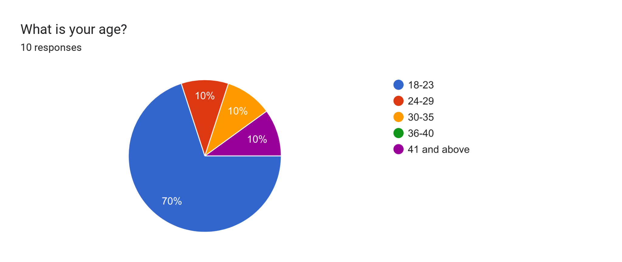

**Figure 1**

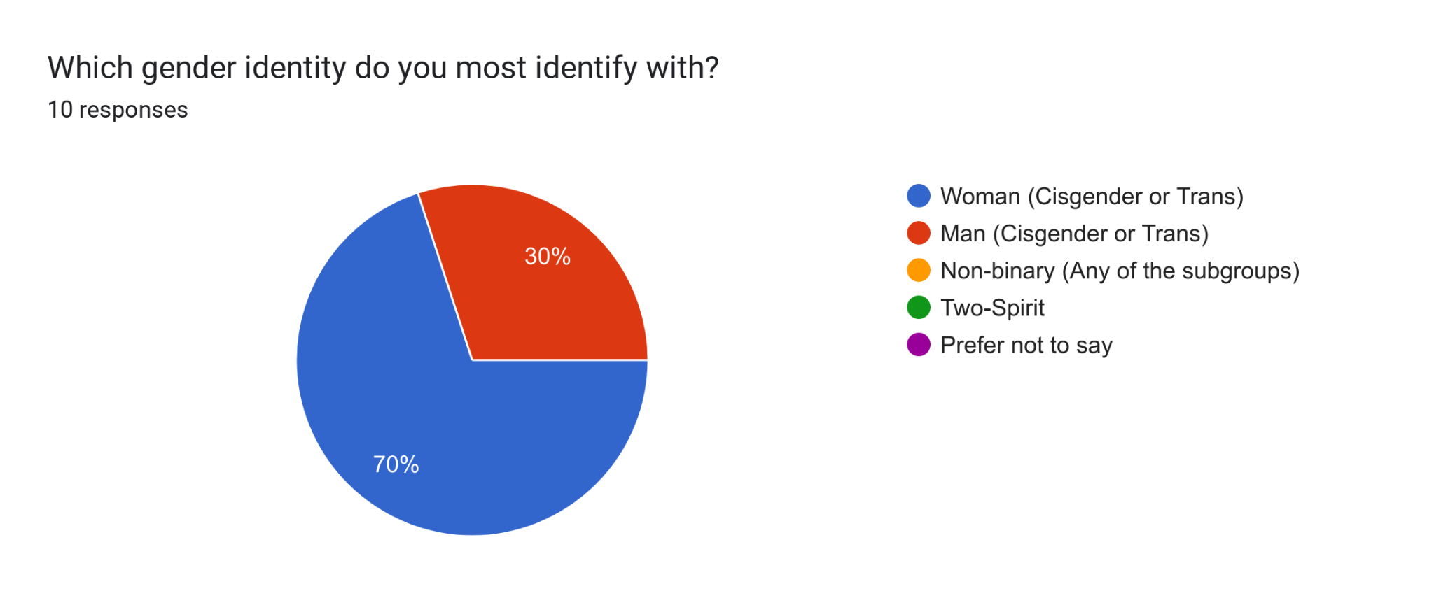

**Figure 2**

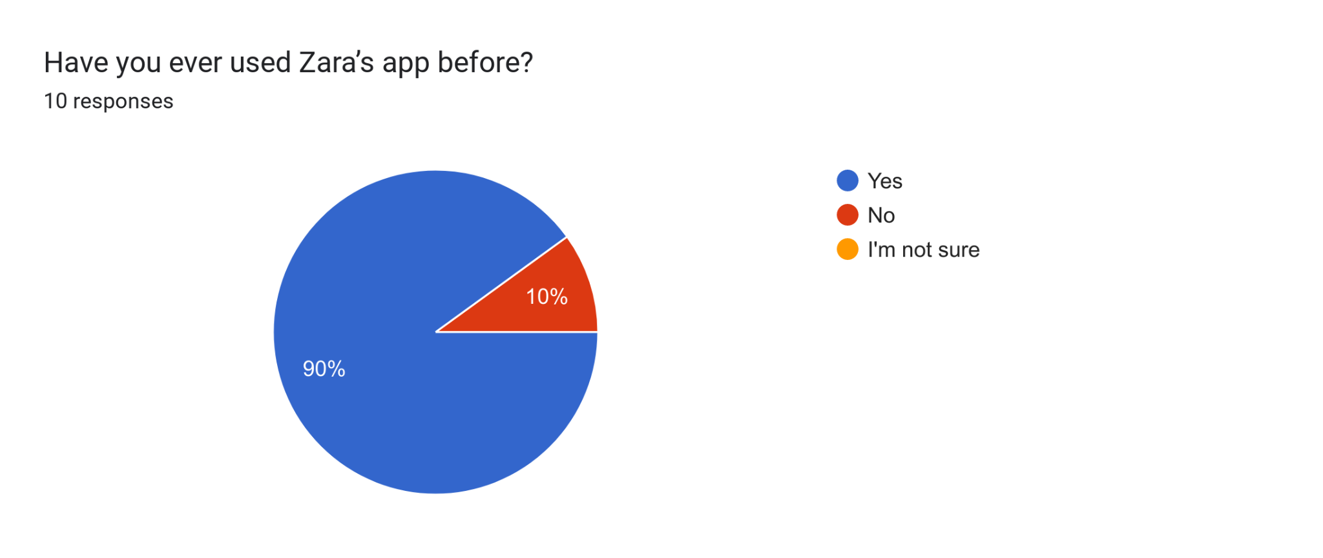

**Figure 3**

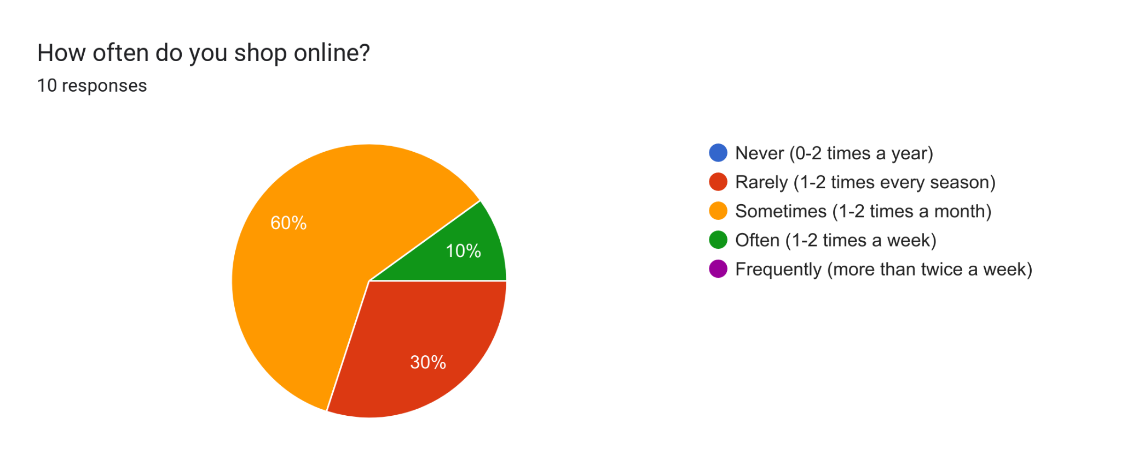

**Figure 4**

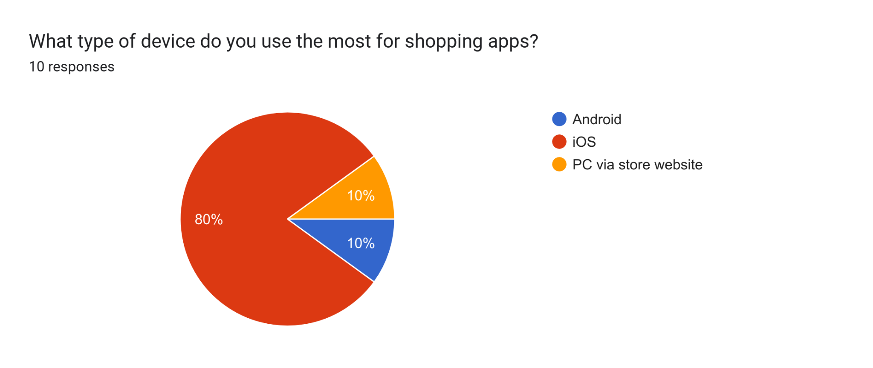

**Figure 5**

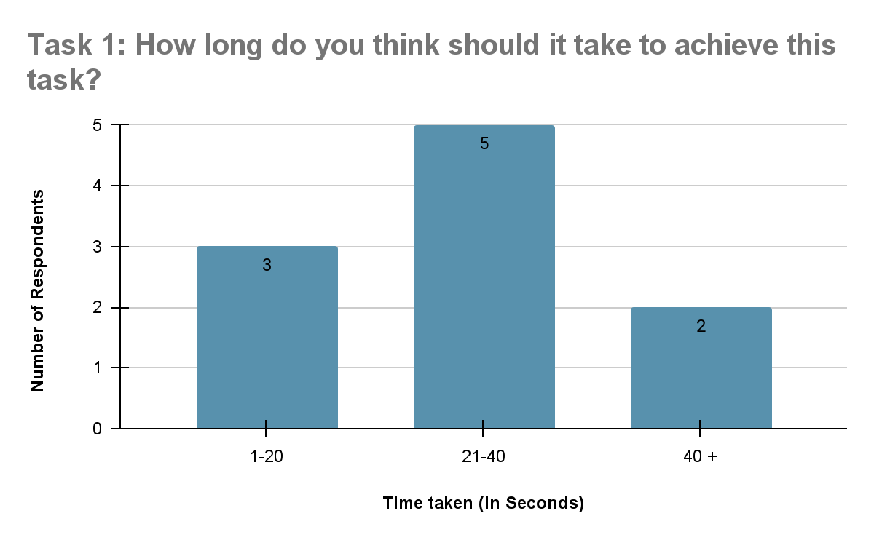

**Figure 6**

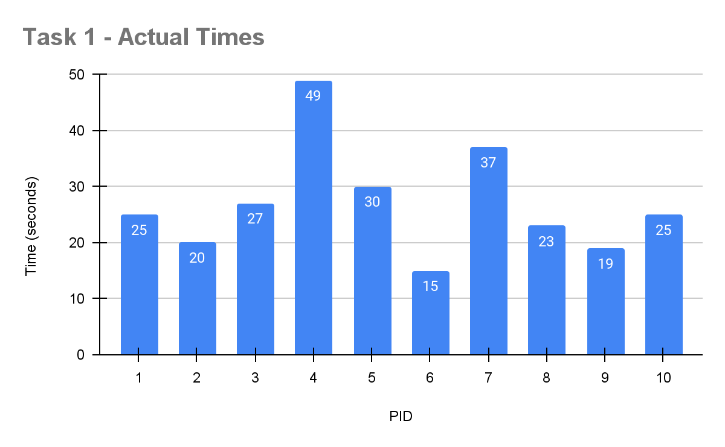

**Figure 7**

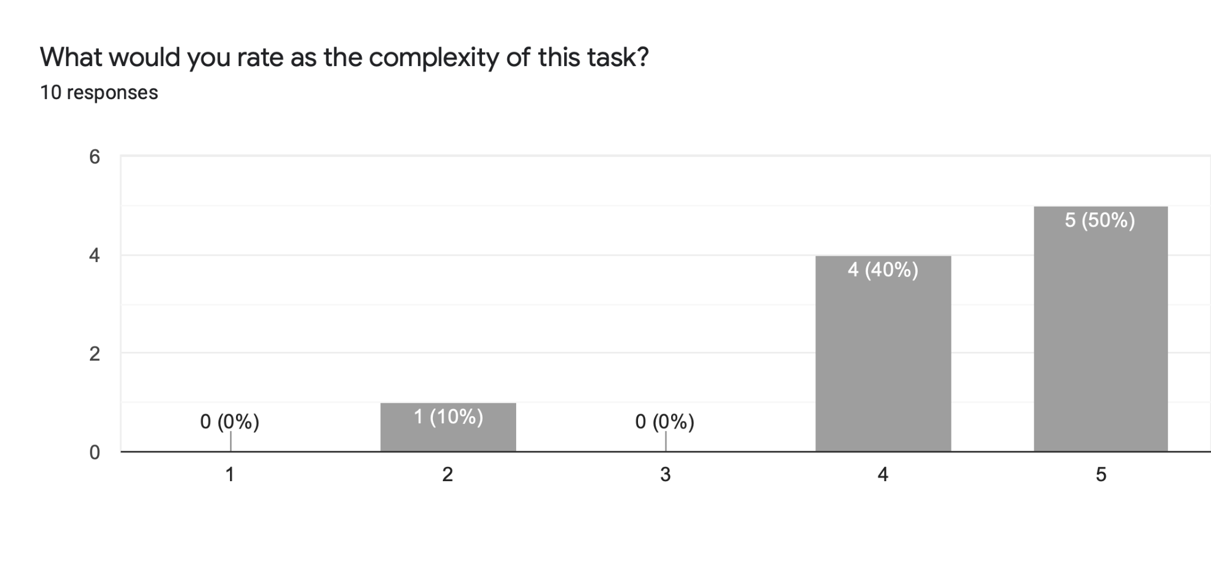

**Figure 8**

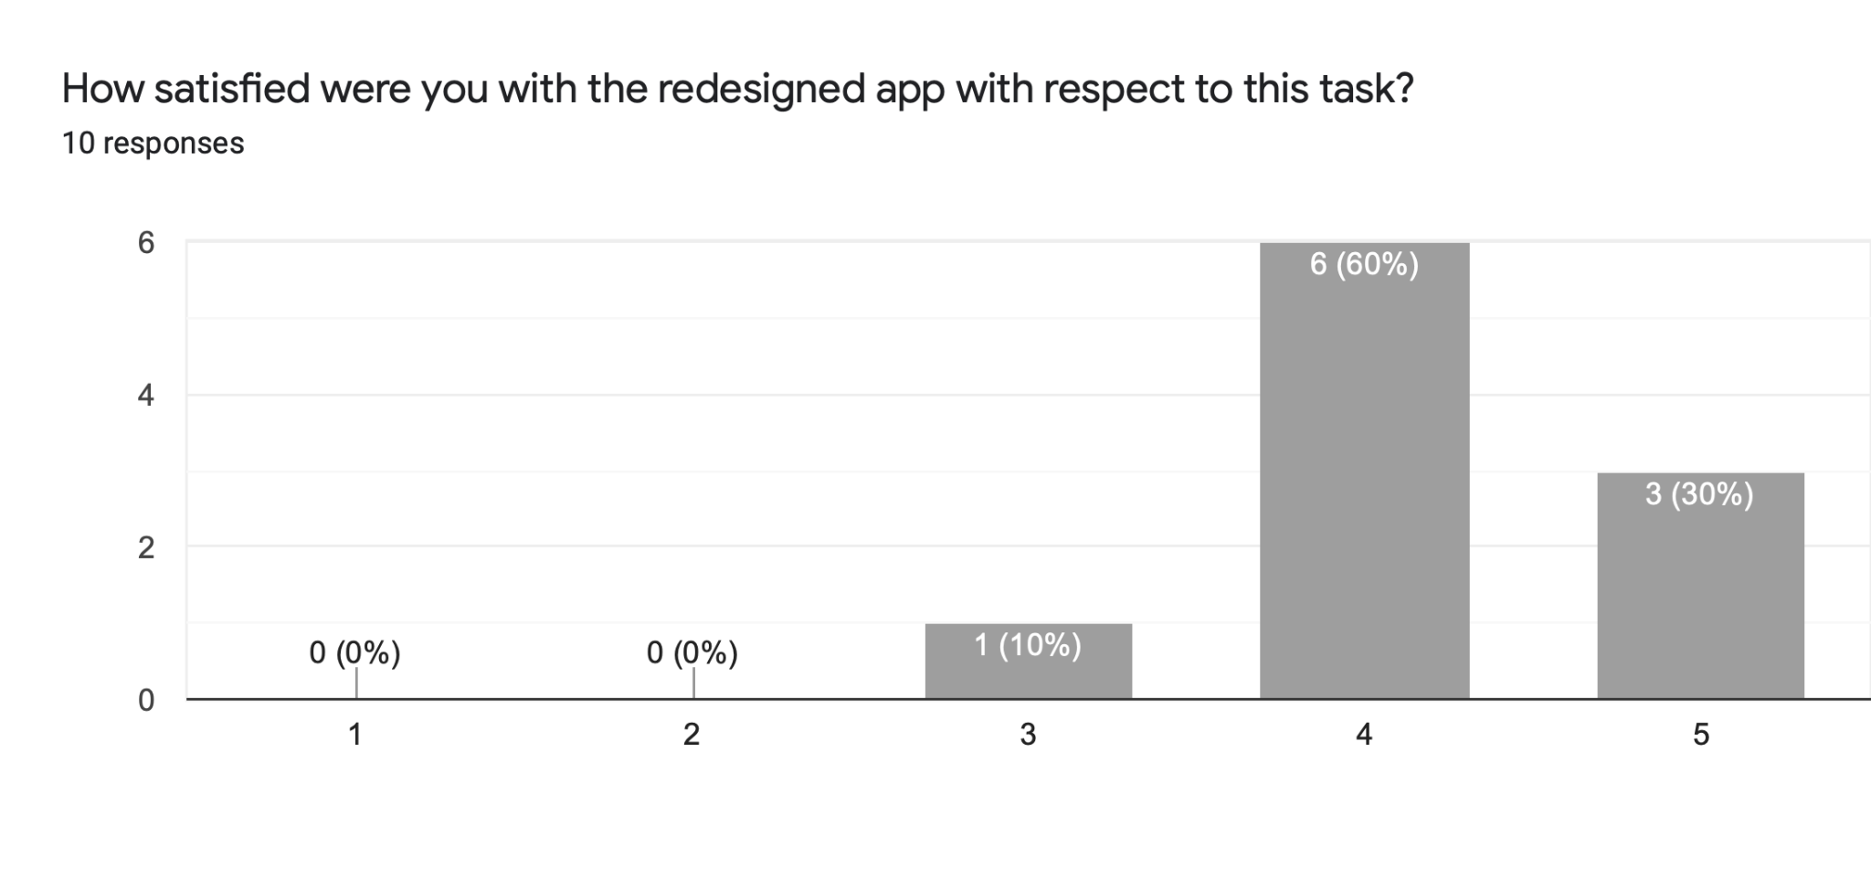

**Figure 9**

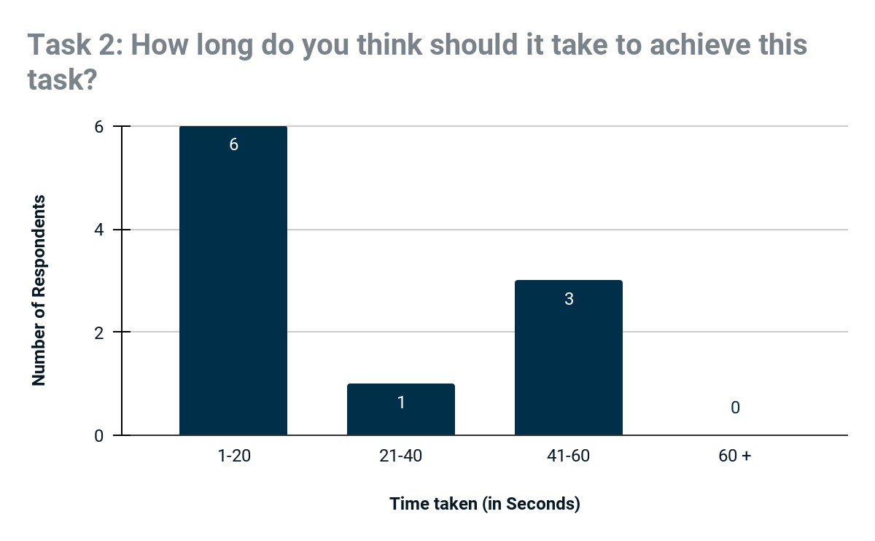

**Figure 10**

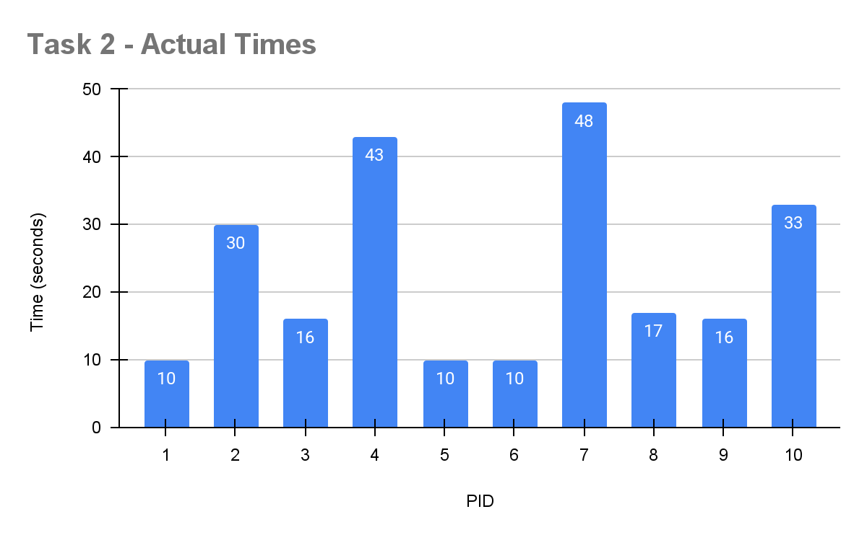

**Figure 11**

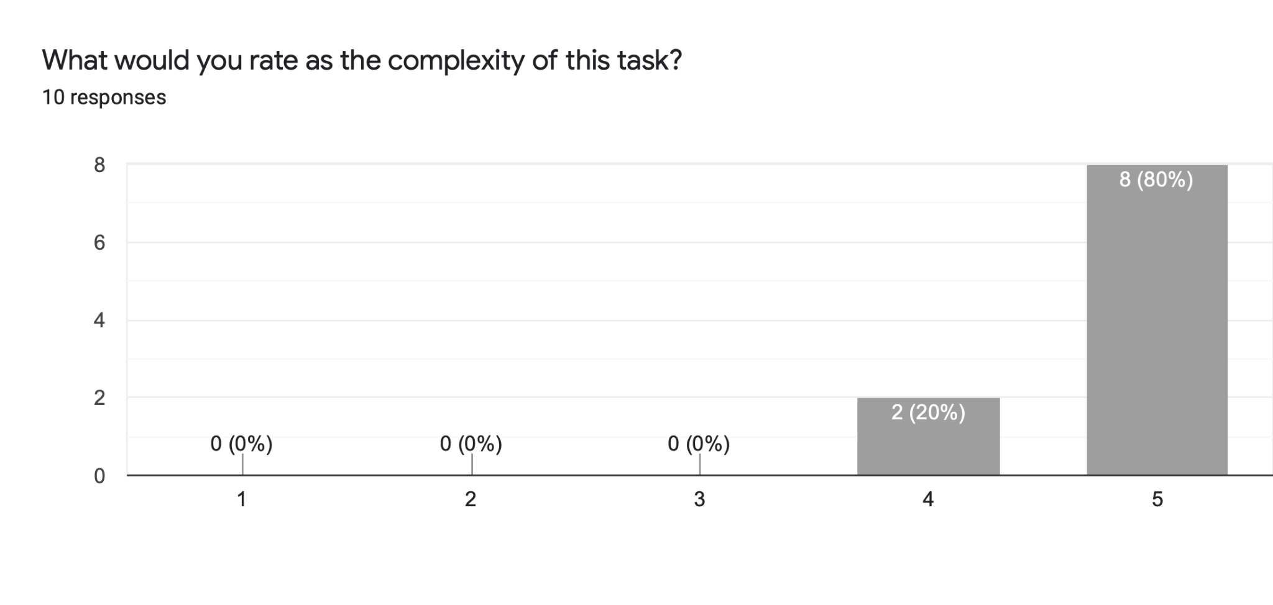

**Figure 12**

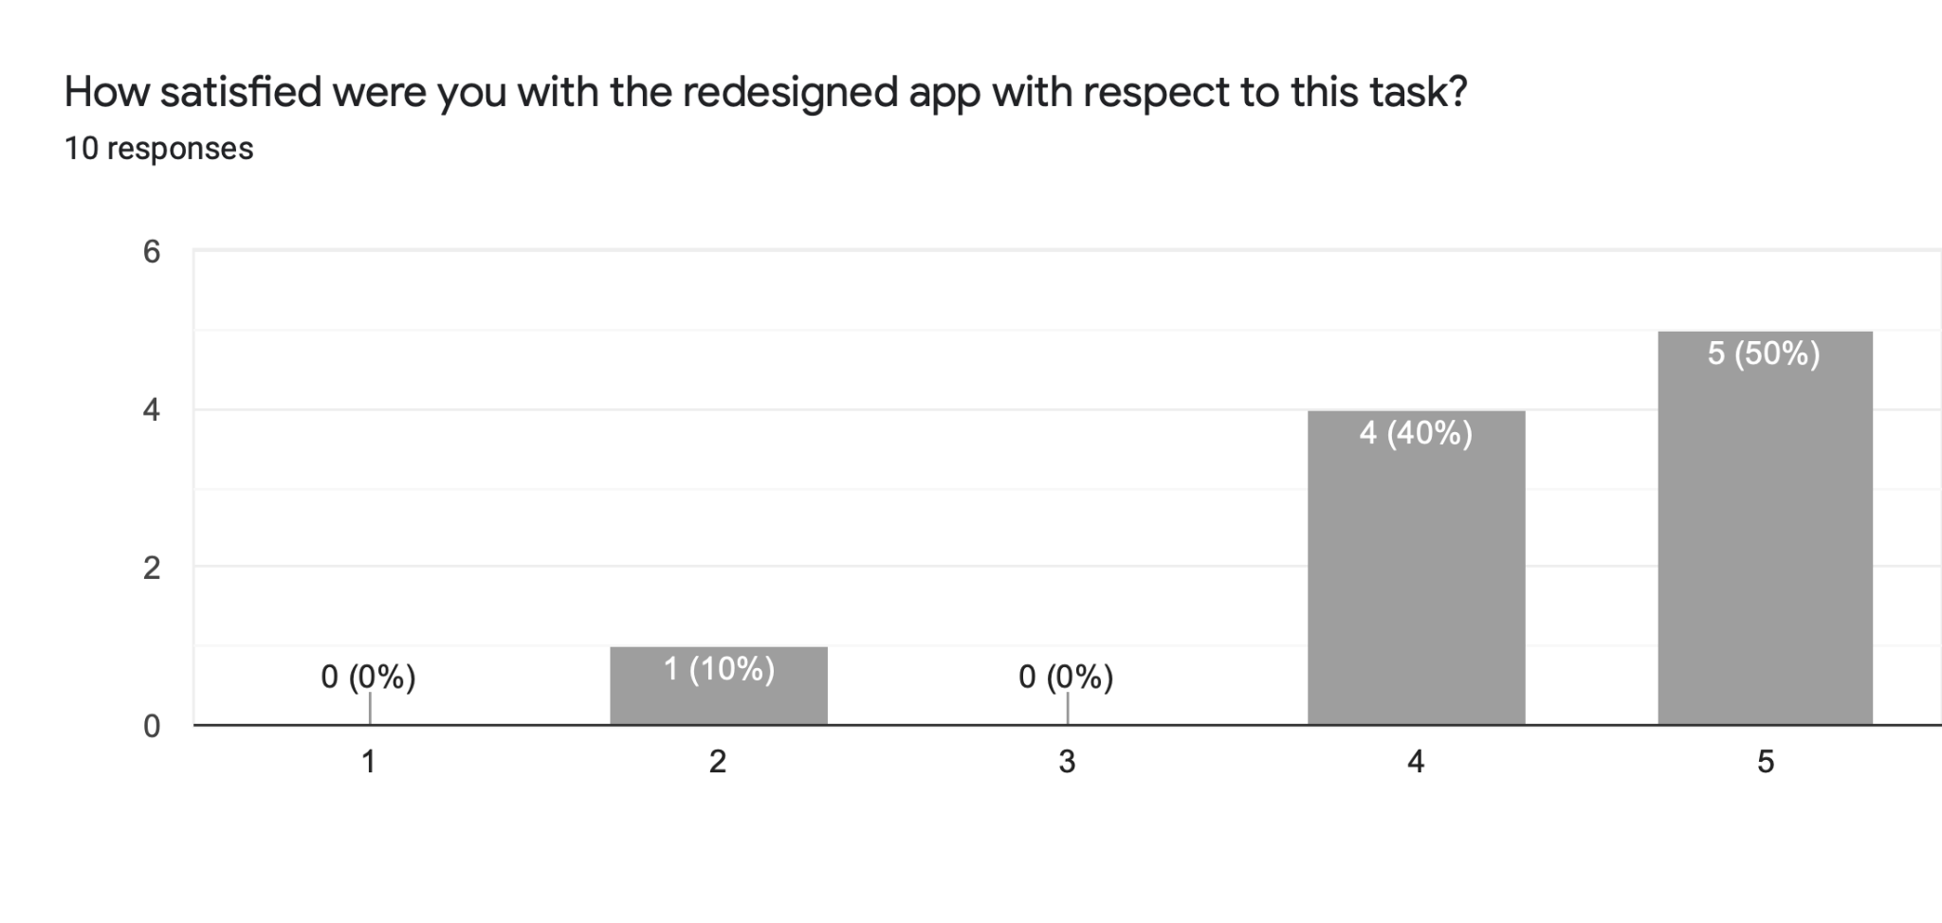

**Figure 13**

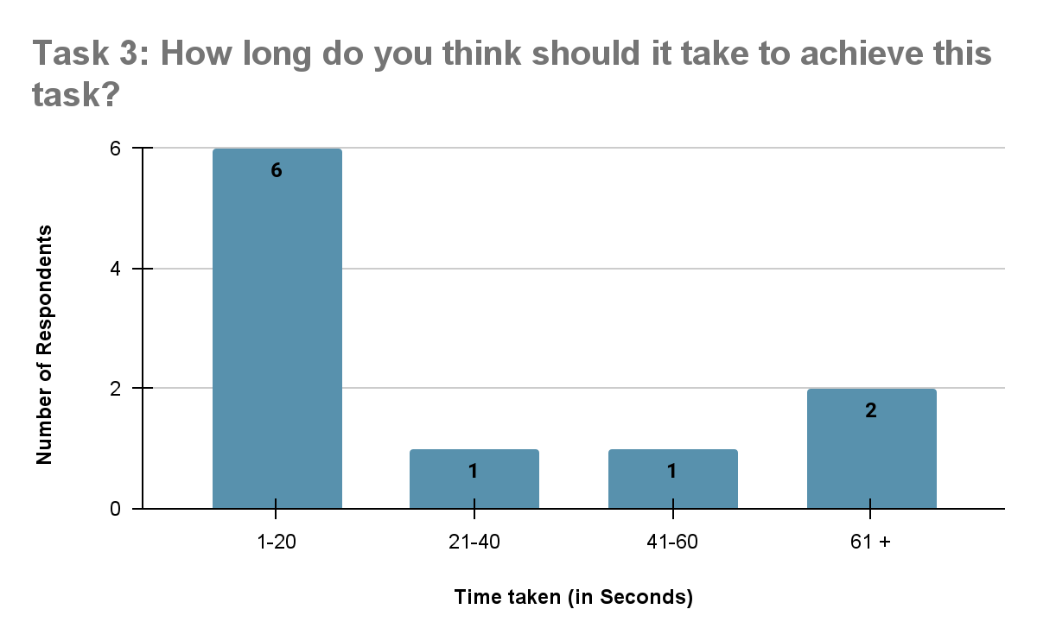

**Figure 14**

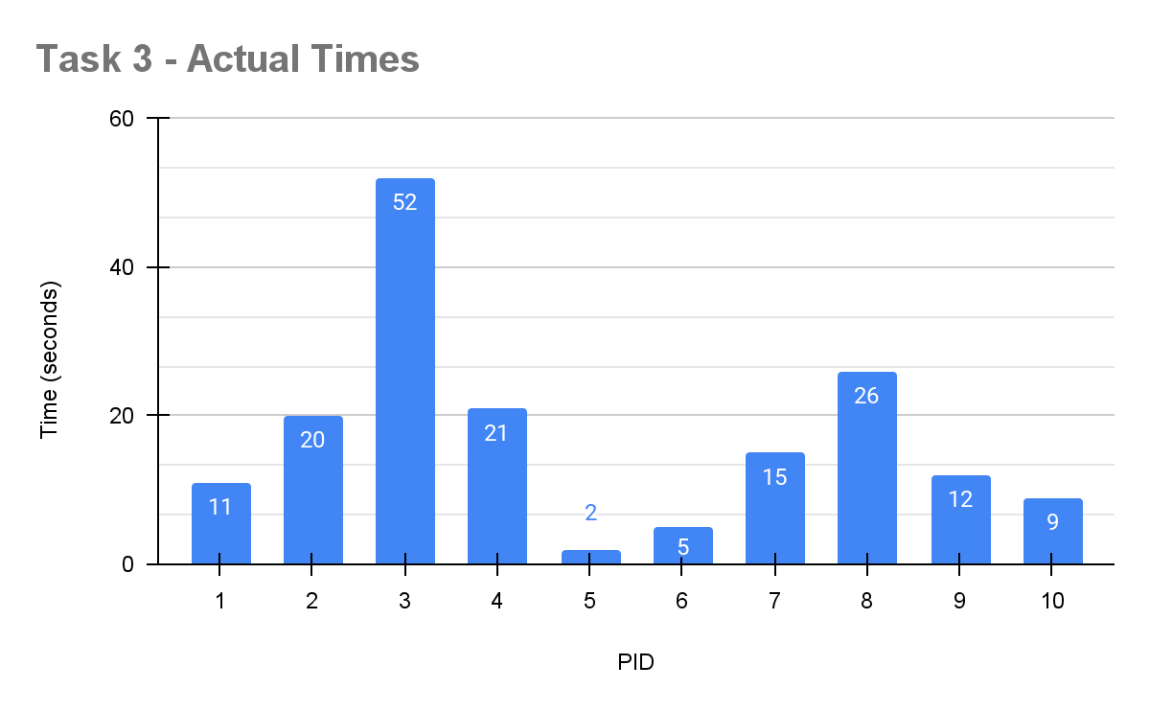

**Figure 15**

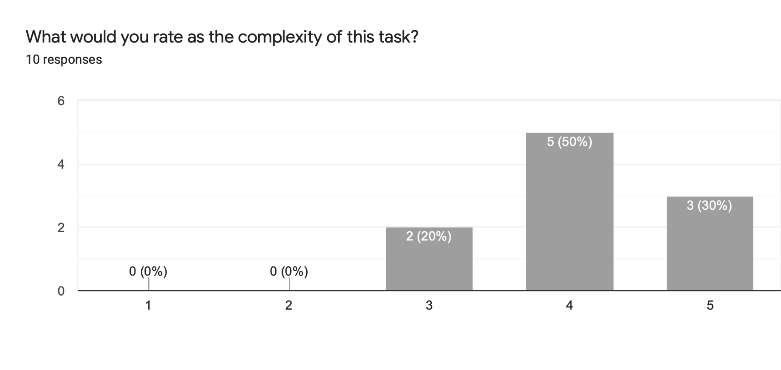

**Figure 16**

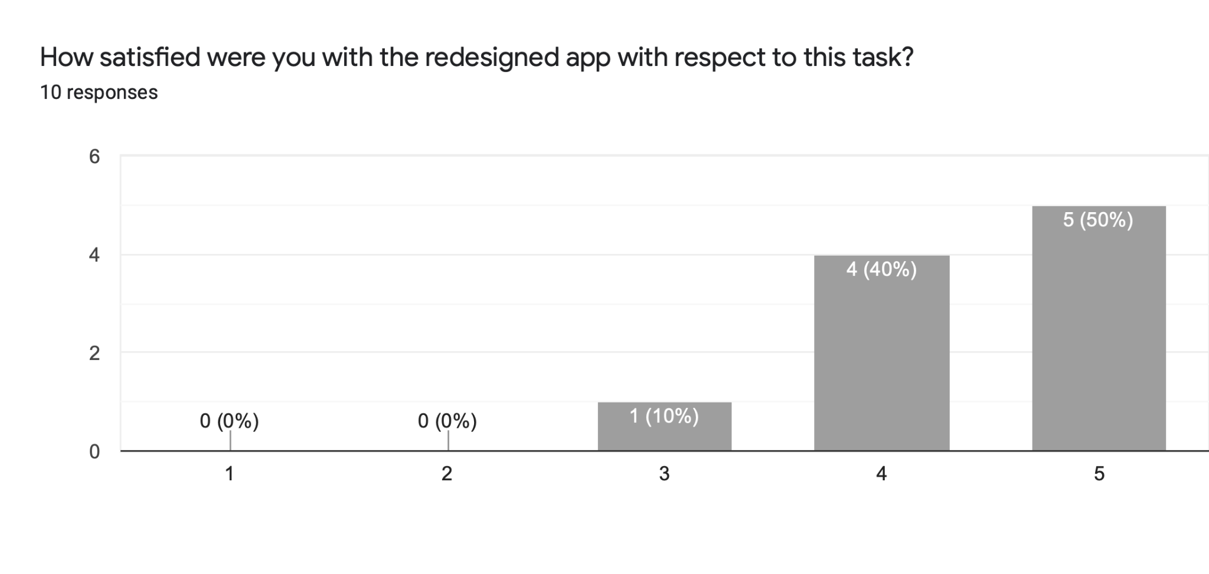

**Figure 17**

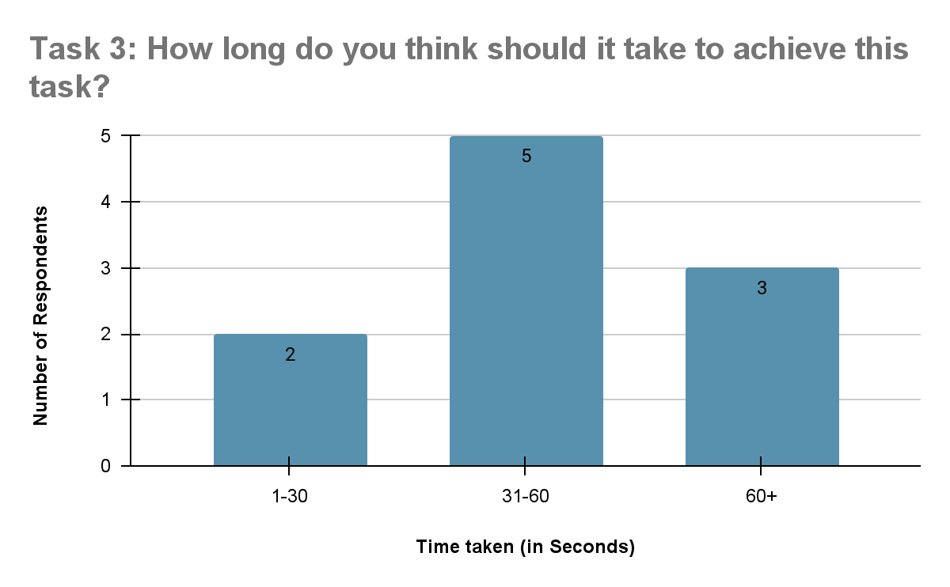

**Figure 18**

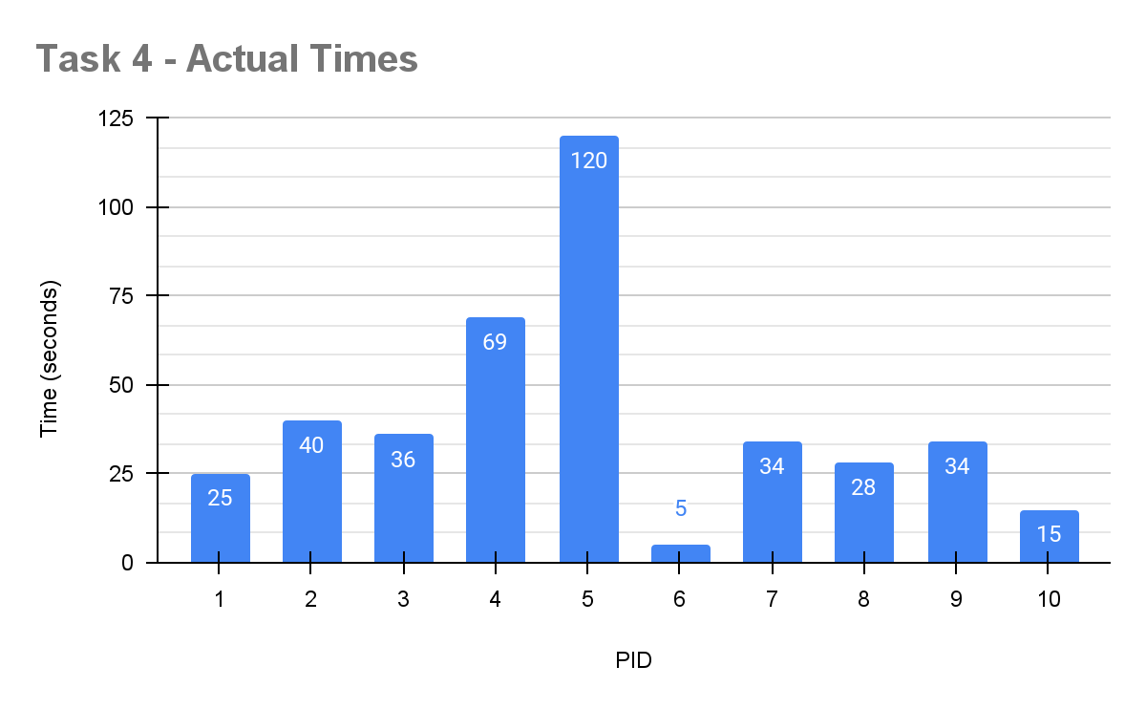

**Figure 19**

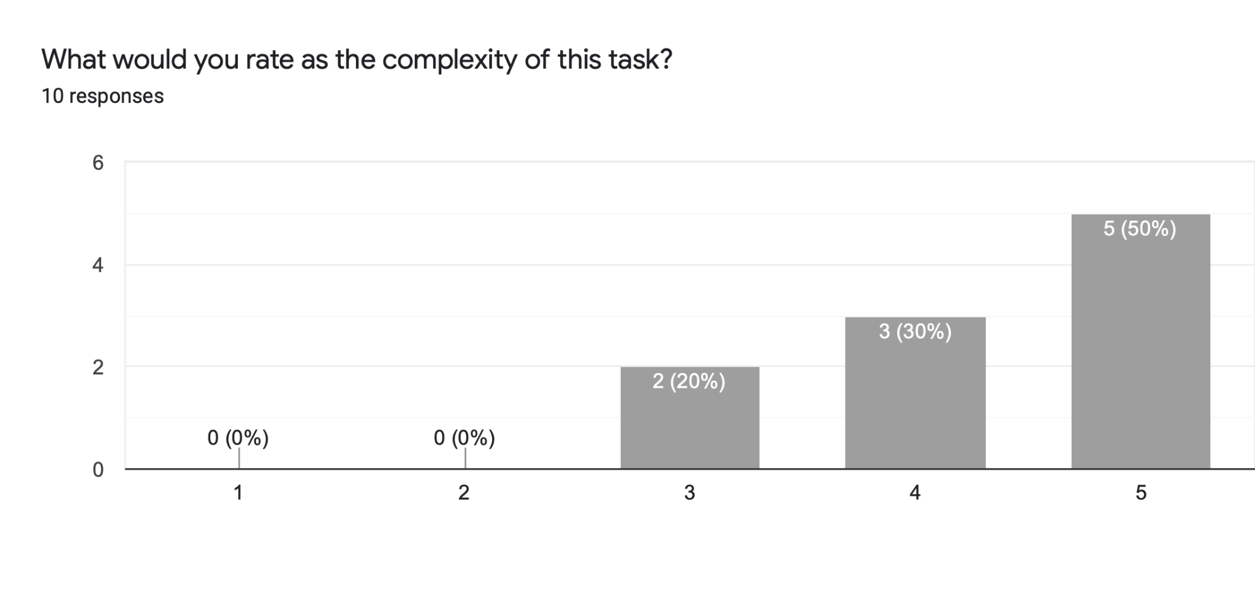

**Figure 20**

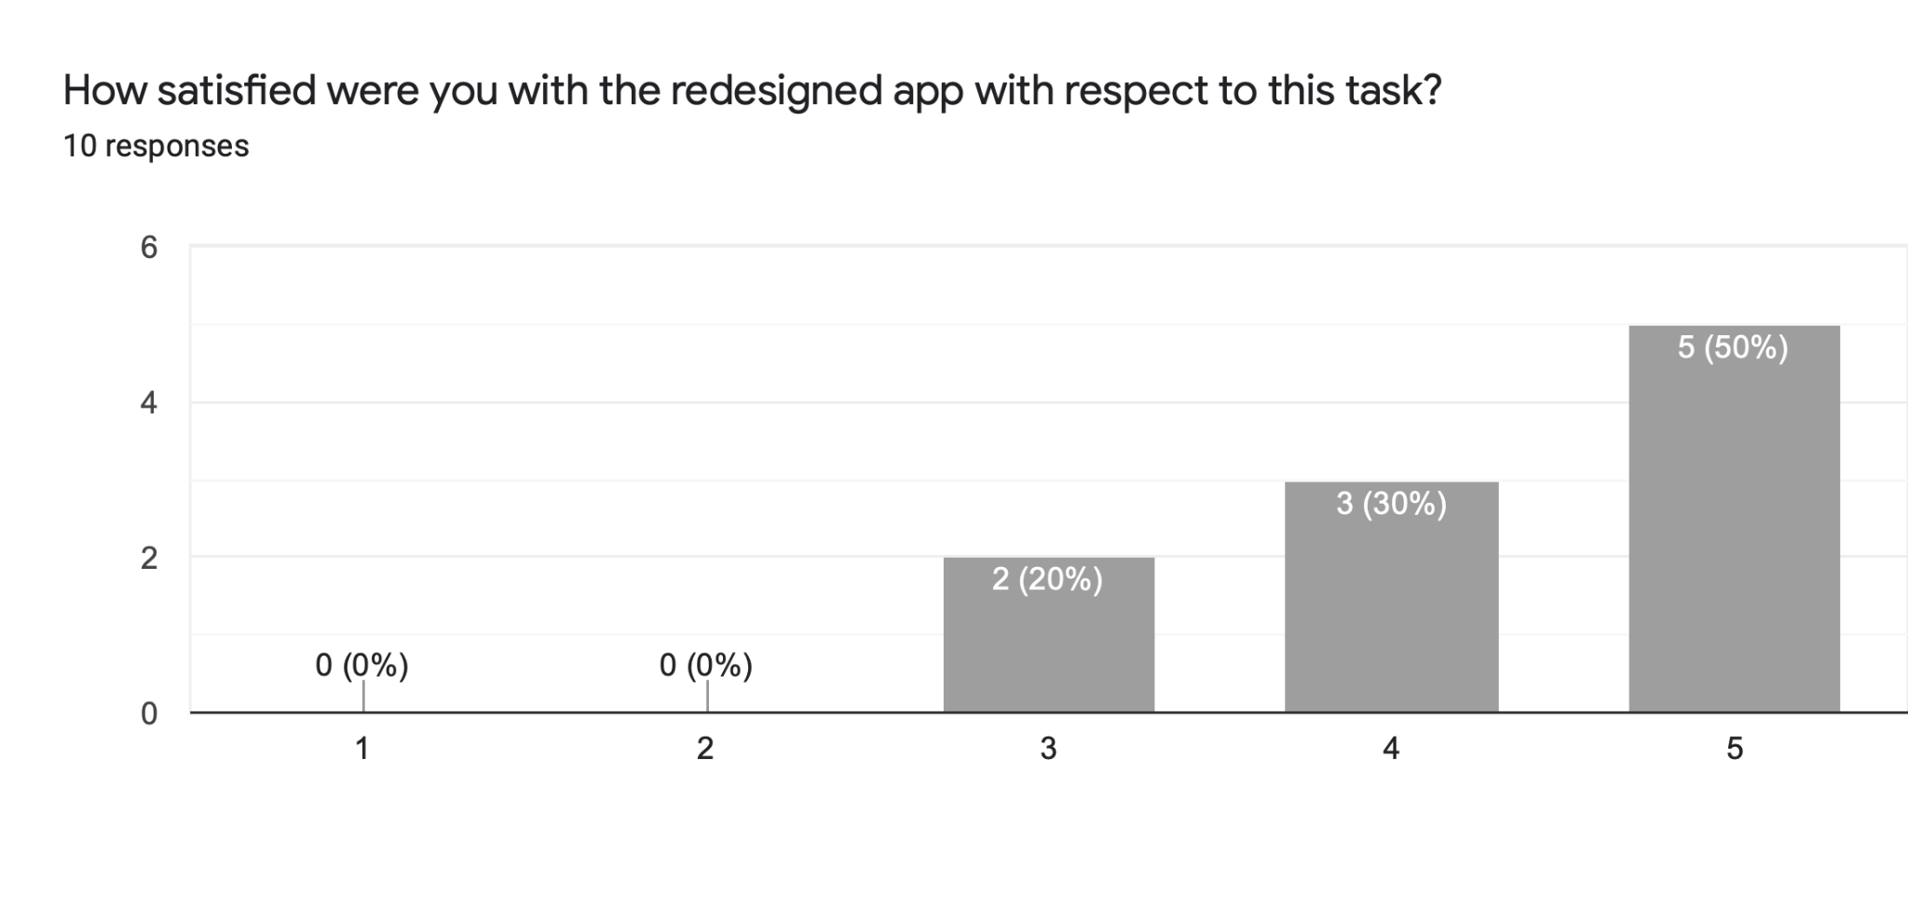

**Figure 21**

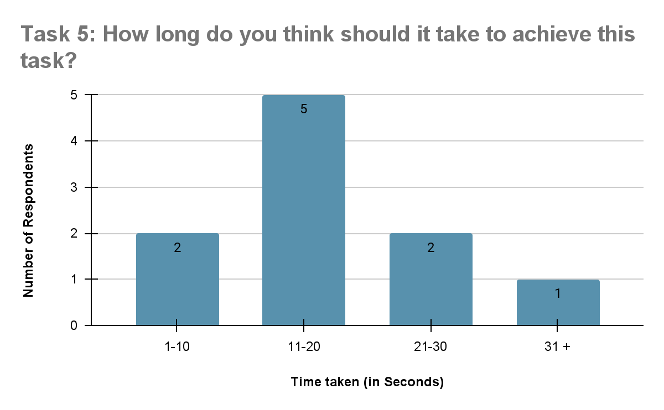

**Figure 22**

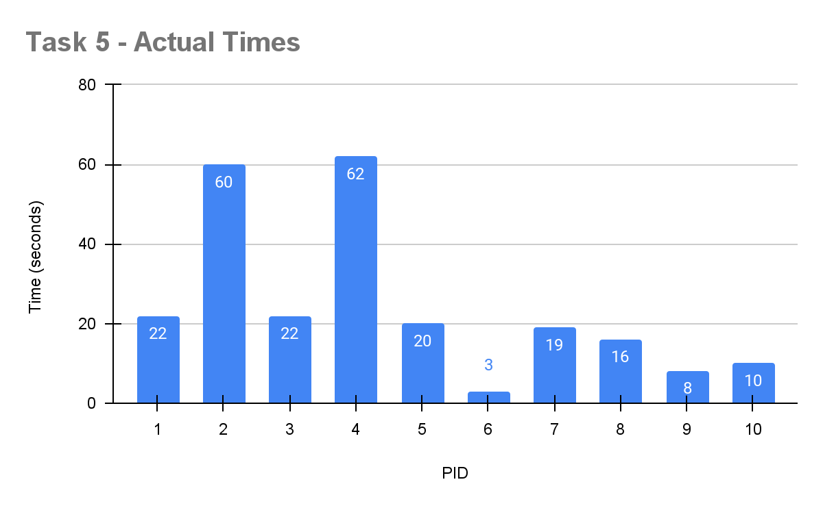

**Figure 23**

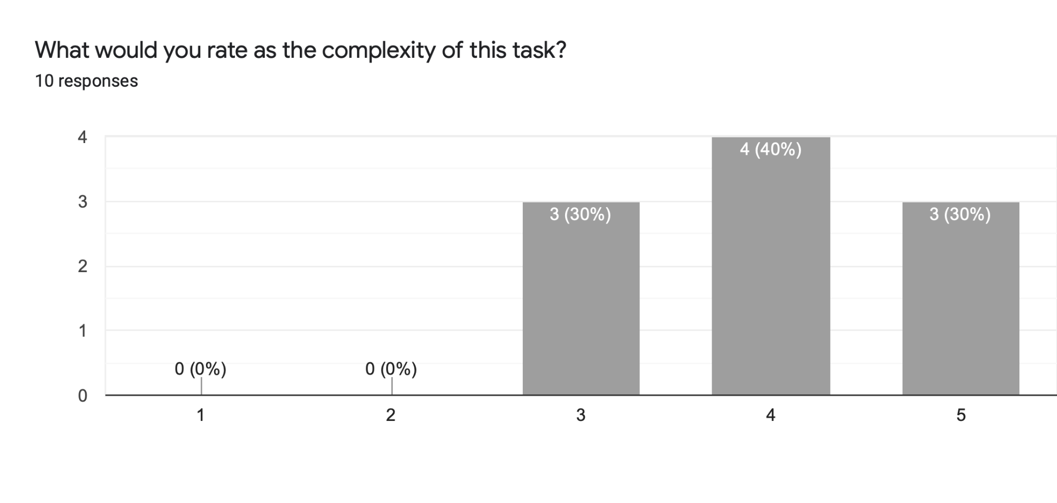

**Figure 24**

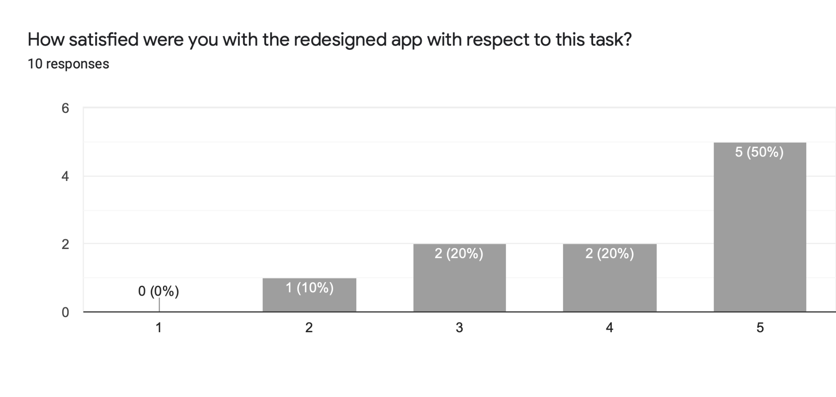

**Figure 25**

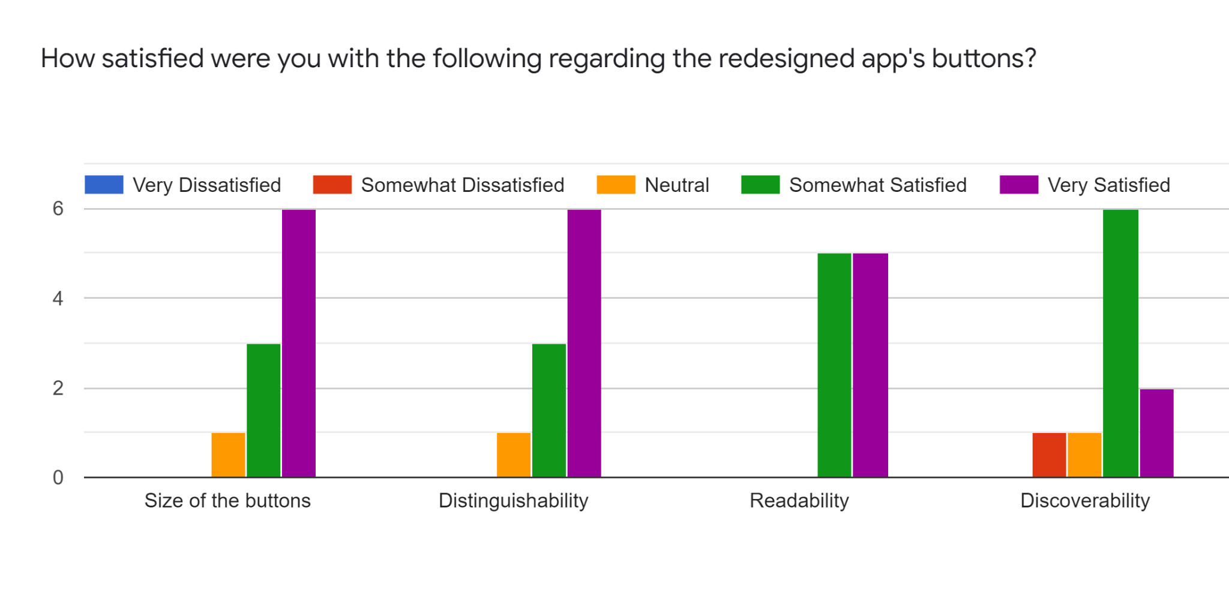

**Figure 26**

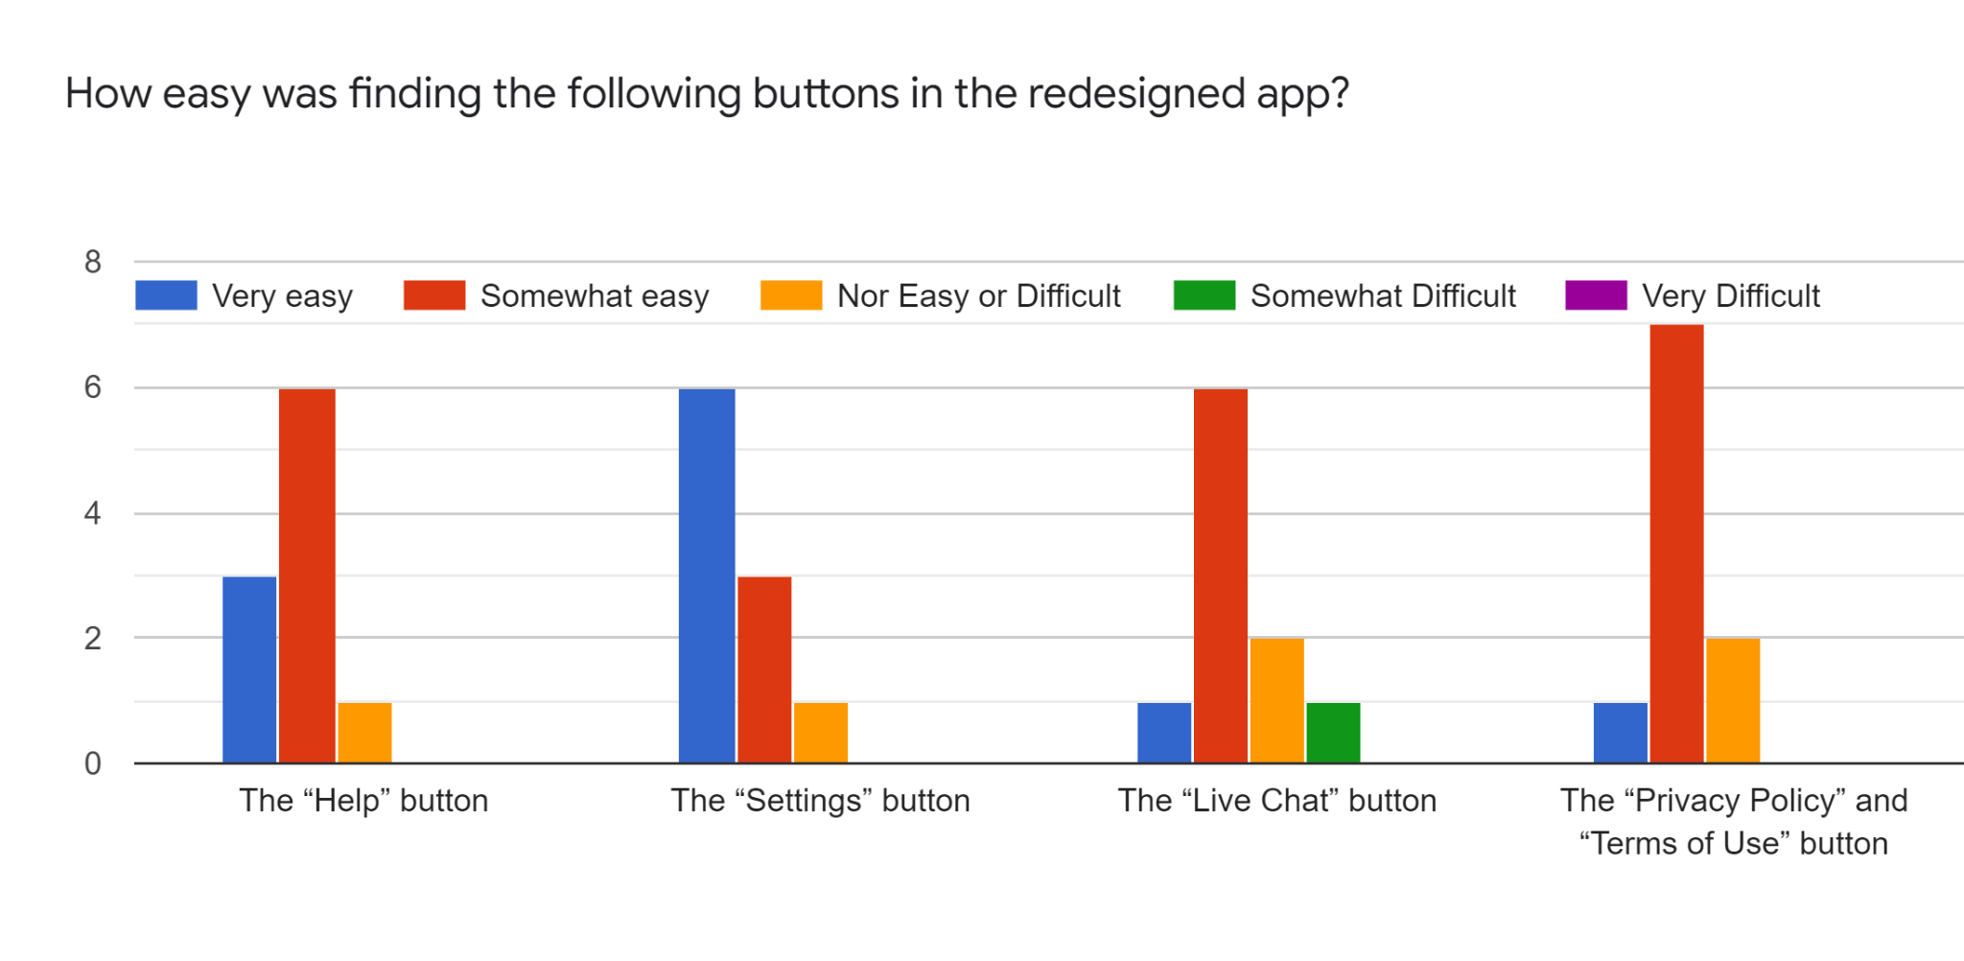

**Figure 27**

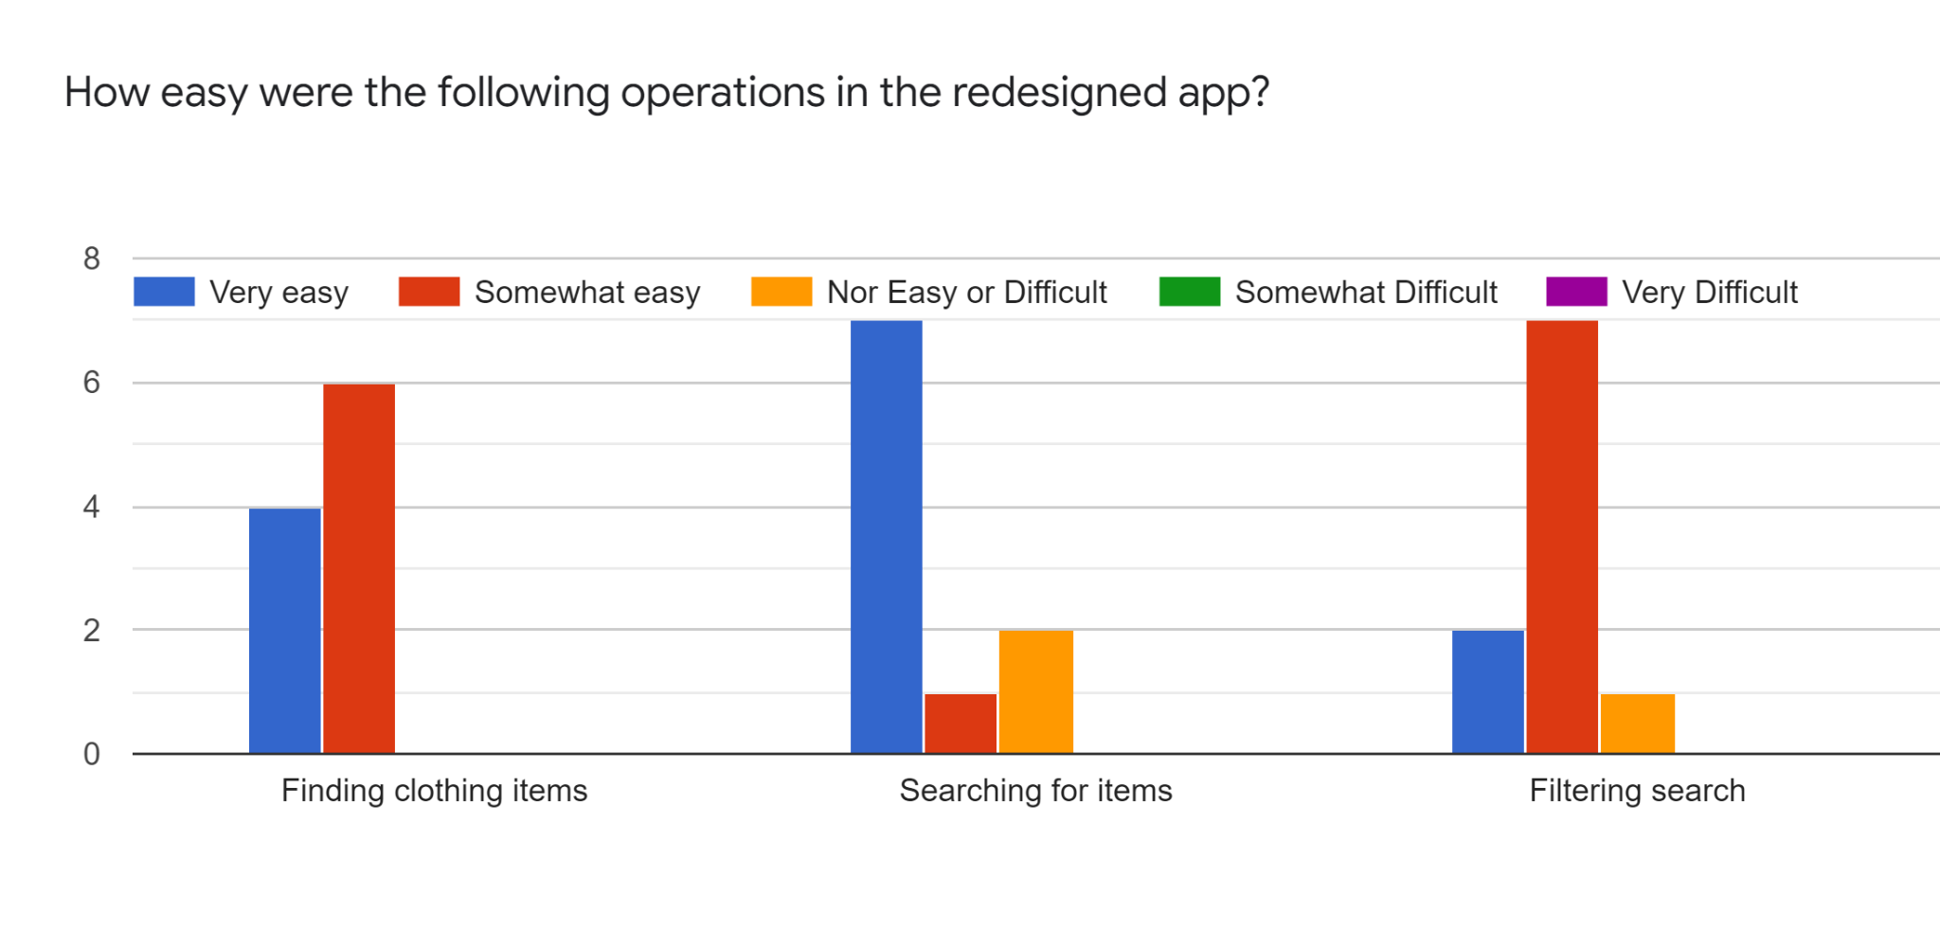

**Figure 28**

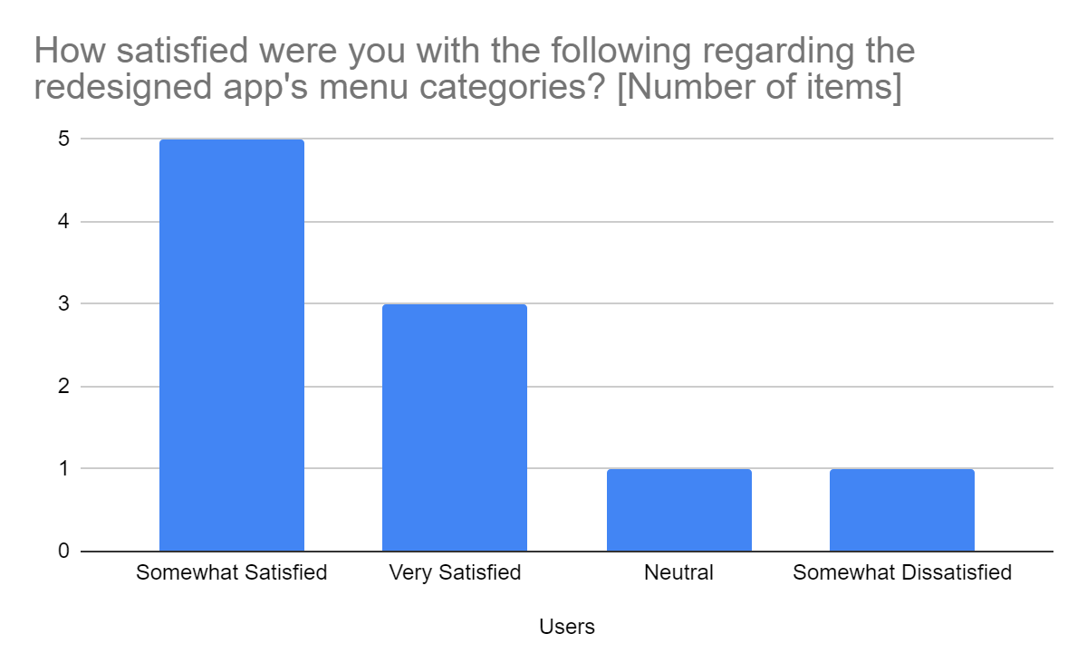

**Figure 29**

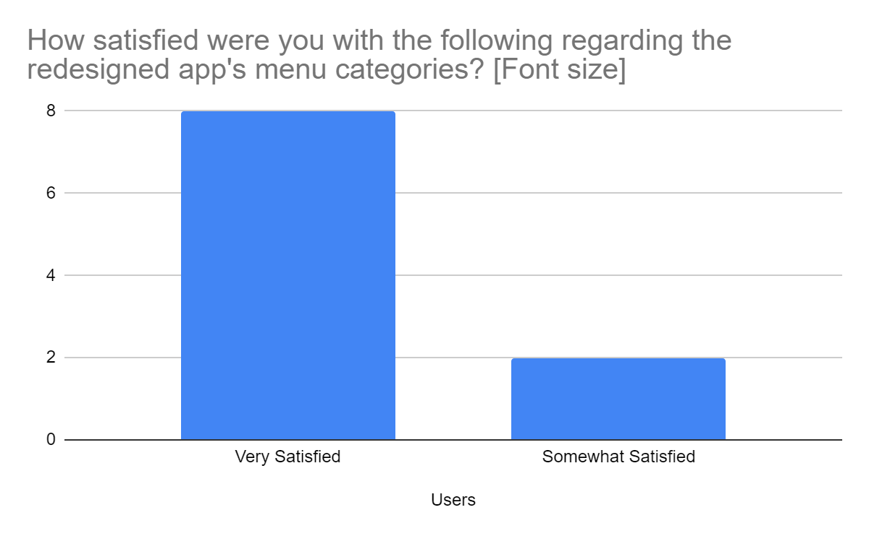

**Figure 30**

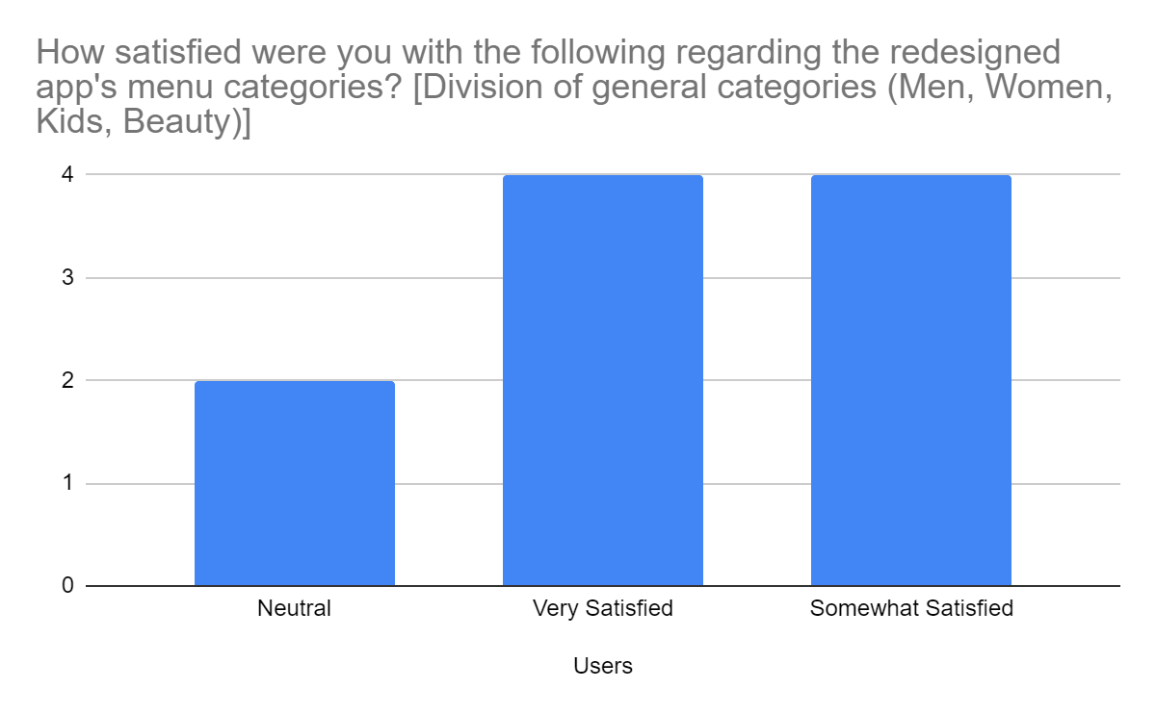

**Figure 31**

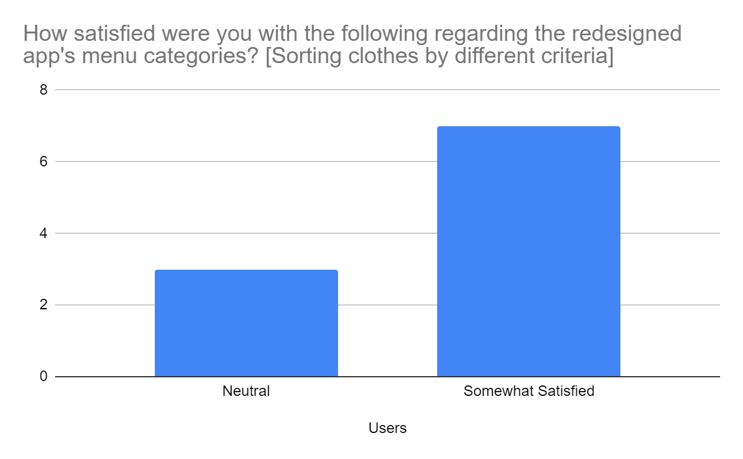

**Figure 32**

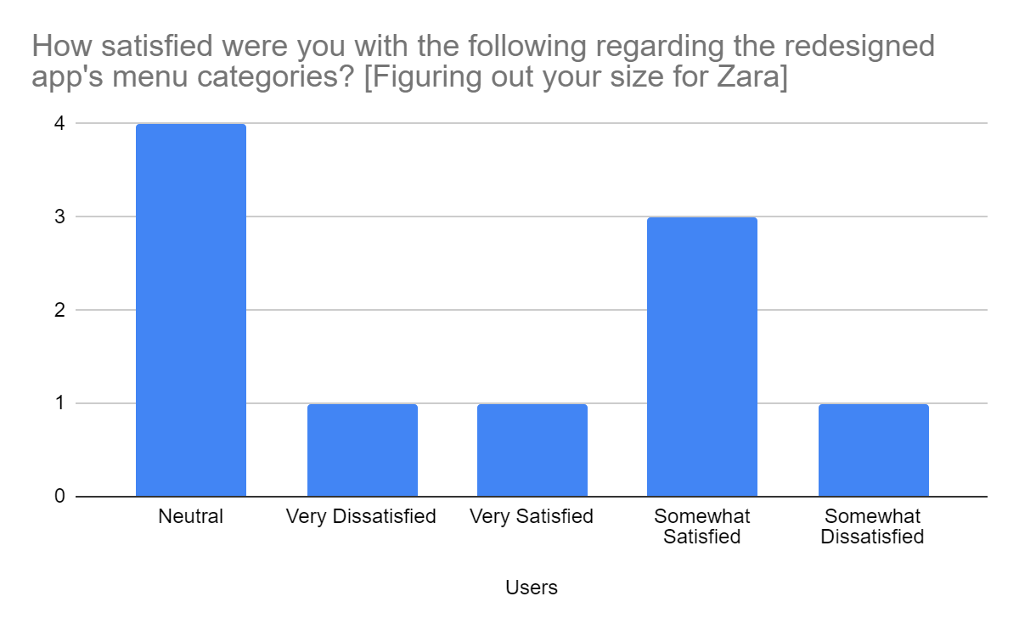

**Figure 33**

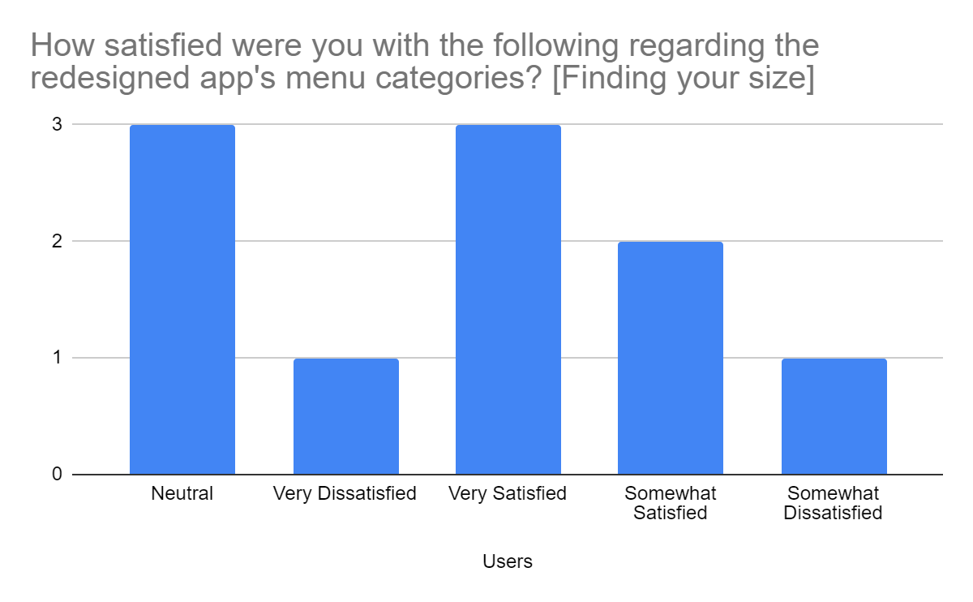

**Figure 34**

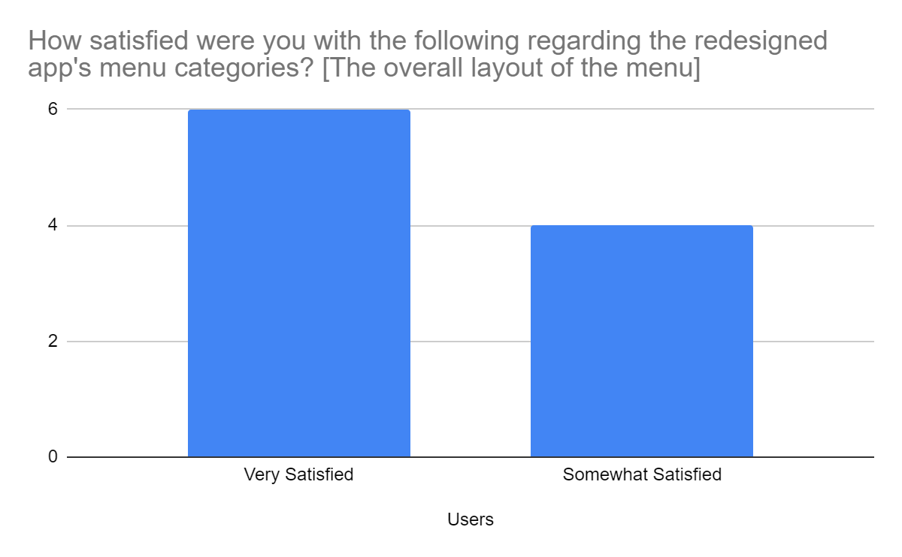

**Figure 35**

______________________________________________________________________________